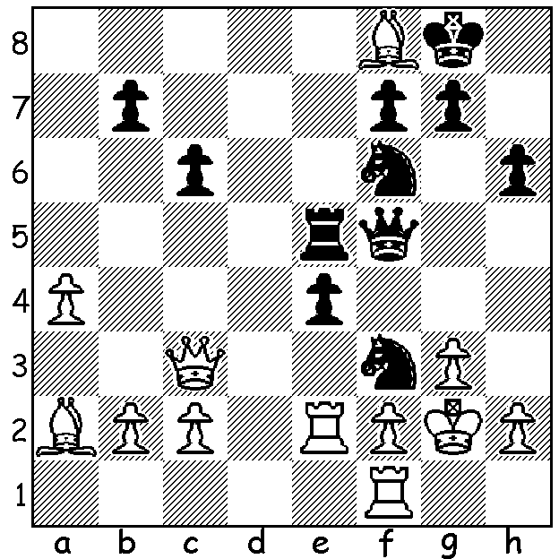
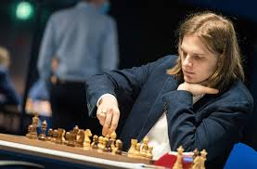
Richard Rapport
Benjamin Bok vs Richard Rapport 2014:
Black mates in 3:

RICHARD RAPPORT WINS GRAND PRIX SECOND LEG
The Second Leg of the 2022FIDE Grand Prix, played in Belgrade during the first two weeks of March, comprised four groups of four players in double round robins with winners advancing. In the semi finals Richard Rapport (Hungary) defeated Maxime Vachier-Lagrave 1.5-0.5 while Dmitry Andreikin (Russia) needed four games to defeat Anish Giri (Netherlands) 2.5-1.5. In the final Rapport defeated Andreikin 1.5-0.5. The top two players from the three leg competition qualify for the next Candidates tournament to find a challenger for the world title with the winner of each GP leg scoring 13 points and the runner-up 10. This means Rapport and First Leg winner Hikaru Nakamura (USA), who are both playing in the Third Leg, are favourites to win these two places.

BEGONIA OPEN: A record 173 players entered the 56th Begonia Open in Ballarat 13-15 March. Joint winners were WA GM Temur Kuybokarov, GM Zong-Yuan Zhao and FM Domagoj Dragicevic, all on 6/7. Temur was also =1st in 2021.

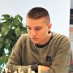


At Ballarat, Temur Kuyokarov & Zong-Yuan Zhao

SOLUTION: 1...Qh3+!! 2.Kxh3 (2.Kh1 Qxh2#) 2...Rh5+ 3.Kg2 Rxh2#.

