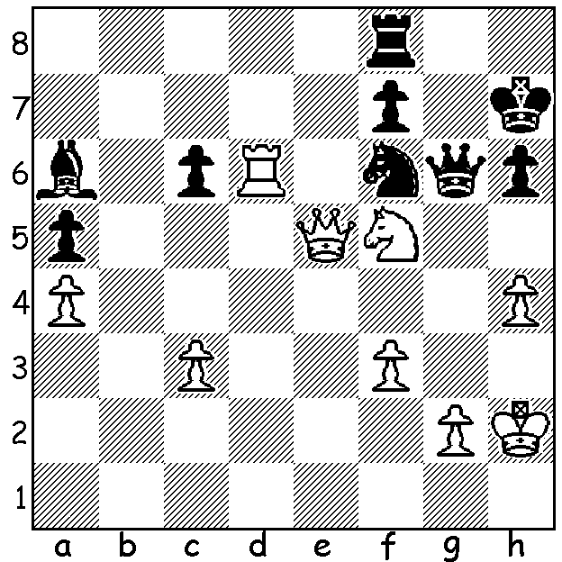
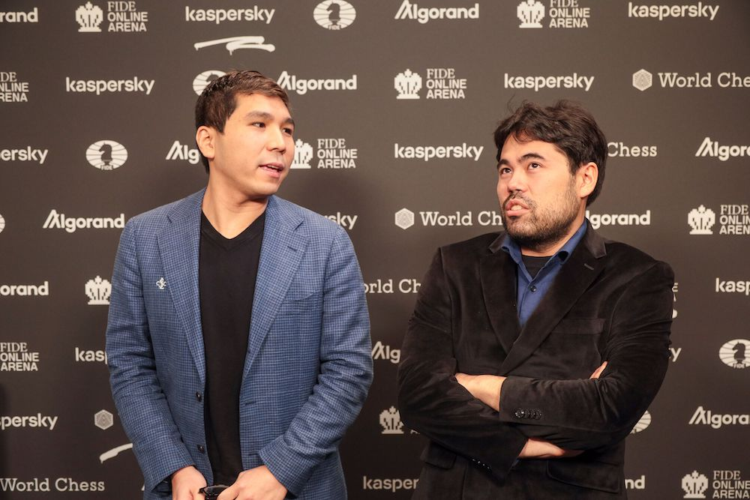
So and Nakamura at Final

Hikaru Nakamura vs Wesley So (Grand Prix Final 2022). The Third Leg of the FIDE Grand Prix finished this week with two Americans, Hikaru Nakamura and Wesley So winning through to the final. After two draws with classic time limits the two players faced each other in two rapidplay games. The position shows a crucial position from the first of these two games. Nakamura has sacrificed a piece for what appears a winning attack. However brilliant defence by So enabled him to draw with 1...Rg8!! with play continuing 2.g3 Re8! 3.Qxf6 Re2+ 4.Kh3 Bc8! 5.g4 Bxf5 6.Qxf5 7.Qxf5 gxf5 and Black saved the rook ending with the value of 1...Rg8 being the exposure of White’s king to a rook check followed by the pin on the knight. I wondered if White could have done better with 2.g4 instead of 2.g3 before seeing Black’s brilliant saving resource. Can you find the move after 2.g4 and the continuation? So outplayed Nakamura in the second rapidplay game to win the tournament.

WA JUNIOR RAPIDPLAY CHAMPIONSHIPS, Wed 13 & Thurs 14 April at Leeming Primary (open 9am, start 10pm). Entry form at cawa.org.au or contact Alan (0439912234).

GUFELD CUP (WA Grand Prix event), Sunday 17, Monday 18 April at Leeming Primary. See cawa.org.au or contact me (ellisd19@bigpind.com or 0439798607).

SOLUTION: 1...Rg8 2.g4 Qxg4!! 3.fxg4 Nxg4+ 4.Kh3 (4.Kg3 Nxe5+) 4...Nf2+! (not 4...Nxe5? 5.Rxh6#) 5.Kh2 Ng4+ draw.

