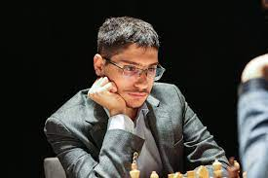
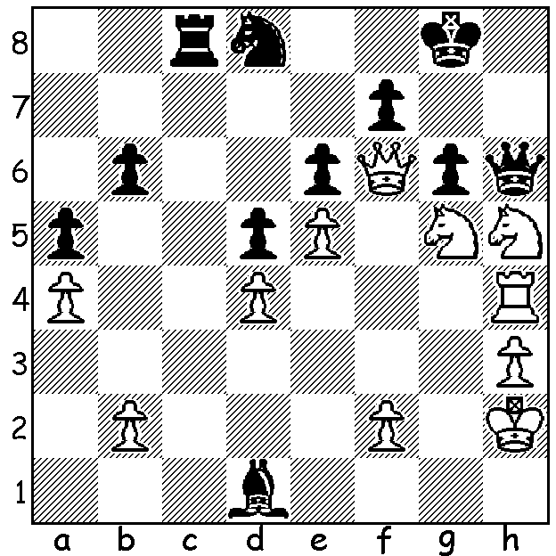
Alireza Firouzja vs Baadur Alireza Firouzja
(European Team Ch 2021)
White to play and win
(5 moves)

2022 CANDIDATES LINE-UP
The Candidates, one if the world’s most important events together with the Olympiad and the World Championship, will be played in Madrid in June. Eight of the world’s best will compete in a double round robin to find a challenger to Magnus Carlsen for the world title. The contestants and how they have qualified are:- Ian Nepomniachtchi (Previous challenger), Teimour Radjabov (given wild card after declining to play in previous Candidates because of covid concerns), Jan-Krzysztof Duda
(winner of 2021 World Cup), Alireza Firouzja & Fabiano Caruana (1st & 2nd in 2021 FIDE Grand Swiss), Hikaru Nakamura & Richard Rapport (1st and 2nd in 2022 FIDE Grand Prix). Sergey Karjakin had qualified as 2nd in the 2021 World Cup but has been banned for expressing support for Putin’s invasion of Ukraine, although the Russian Chess Federation is appealing against his ban. Instead the final place will be offered to the highest eligible rated player. Ding Liren (2799) is rated 3rd behind Carlsen and Firouzja but at present has not played enough games (30) in the last year to be eligible due to China’s strict covid restrictions. However China is organising events to enable him to play the 26 games needed to reach the target although he risks losing rating points and falling behind Levon Aronian (2788).
.

GUFELD CUP (WA Grand Prix event), Sunday 17, Monday 18 April at Leeming Primary. See cawa.org.au or contact me (ellisd19@bigpind.com or 0439798607).

SOLUTION: 1.Qxd8!! Rxd8 2.Nf6+ Kg7 3.Rxh6 Kxh6 4.Nxf7+ / 5.Nxd8. Four common combinative themes occur in the solution – clearance sac, remove the guard, discovered attack with check and fork.

