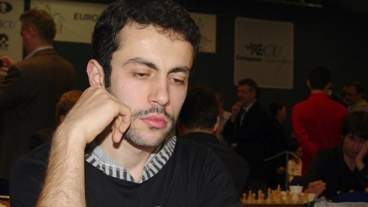
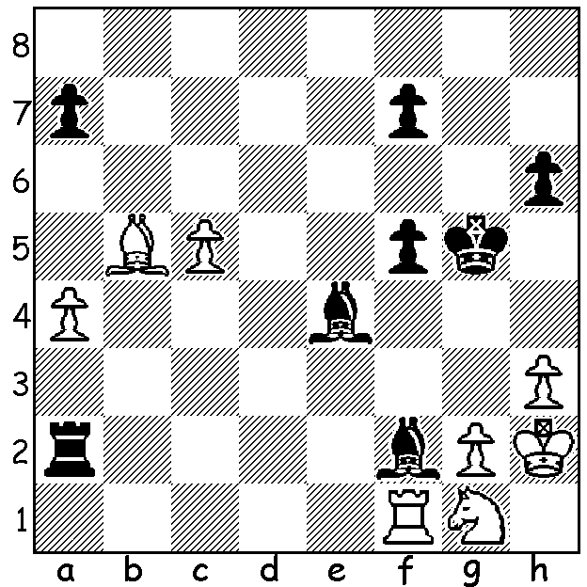
Robert Zelcic vs Hrant Melkumyan 2019 Hrant Melkumyan
Black to play and win:

TO REPEAT OR NOT REPEAT, THAT IS THE QUESTION.
The Doeberl Cup, played annually in Canberra since 1963, attracts many of Australia’s top players as well as a number of international grandmasters. Played this year from April 14 to 18, the Premier had 53 entrants while Major, Minor and Under 1200 competitions were also played as well as an open one day Blitz. At the start of the final round West Australian Temur Kuybokarov, Australian and Open Australian champion, was tied with Armenian GM Hrant Melkumyan. Temur’s game was drawn by repetition* while Hrant was also faced with a repetition in his game against Igor Bjelobrk. However Igor, in a quest to win, avoided the repetition and blundered into a mate, leaving Hrant the winner with 7.5/9 and Temur second on 7. Hrant, whose partner is Australian international Emma Guo, a past winner of the Oceania Womens Championship, also won the event in 2019. Dennis Holland was another West Australian playing and scored 4.5/9, his best result in a number of visits and the same score as six-times Australian champion, Darryl Johansen.
(* a draw may be claimed if the same position occurs three times with the same person to move each time)

SOLUTION: 1...Bg3+! (clearance sacrifice) 2.Kxg3 Rxg7# or 2.Kh1 Bxg7#.

