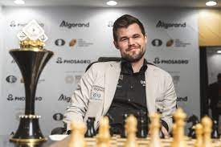
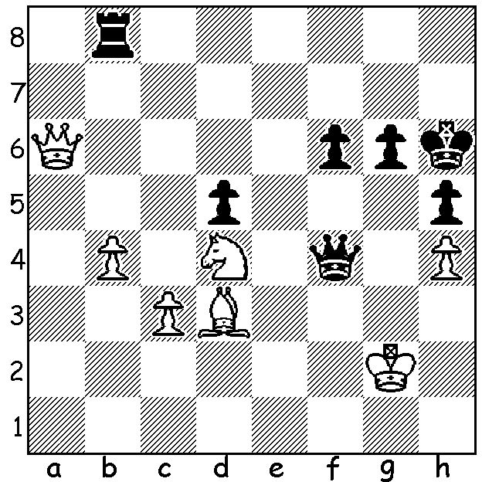

Magnus Carlsen vs Magnus is due to defend his title as
Maxime Vachier-Lagrave 2006 world champion early next year but
White to play and win: it is uncertain whether he wishes to.

I was busy with chess activities earlier this month with two tournaments to direct or assist in directing as well as playing my evening tournament games. The 2022 WA Junior Rapidplay was played at Leeming on April 13 and 14 where I was assisting CAWA President Alan Wolstencroft. Entrants were divided into three groups, 15 in Under 18 / Under 15, 23 in Under 12 / Under 10 / Under 8 and 14 in a competition for those new to tournament play.
Winner of Under 18 was Rebo Fu (9/9) with Teh Rui Gen 2nd (8) and Celine Ong 3rd (6, Girls Champion). Under 15 champion was Teh Rui Gen (5.5)
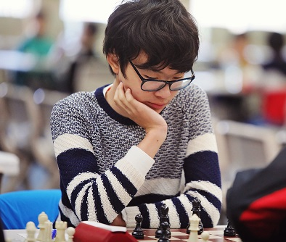
Under 12 champion was Anthony Nguyen (7.5/9) with Yonal De Vas second on 7. Under 10 champion and Girls Under 12 champion was Senudi Di Vas with 6. Three players, Kaviru Perera, Leong Gong and Thomas Yuen, tied in the Under 8 group with
Kaviru wining the play-off. The Newcomers was won by
Rayden Oliveiro with 9/9.

The Gufeld Cup (WA Grand Prix event) held at Leeming
over the Easter weekend was also won by Rebo Fu (5/6)
with Tim Hare 2nd on 4.5. Under 1800 joint winners were
Ned Tomic and Teh Rui Gen both on 4 with Rafiei Daryoush
the top Under 1500 (4) and Hardy Dai (3) gaining the Under
1500 / Unrated prizes.
Rebo Fu

Results of all tournaments can be found on cawa.org.au where entry forms for events can also be found including the 2022 WA Chess Championships, May 15 to July 3 and 2022 Summer Allegro, tomorrow, Sunday May 1..

SOLUTION: 1.Nf5+! (interruption and deflection sacrifice); 1...gxf5 2.Qxf6+ Kh7 3.Bxf5+ Kg8 4.Be6+ Kh7 5.Qxf4 (if 1...Kh7 2.Qa7+ Kg8/h8 3.Qg7#).

