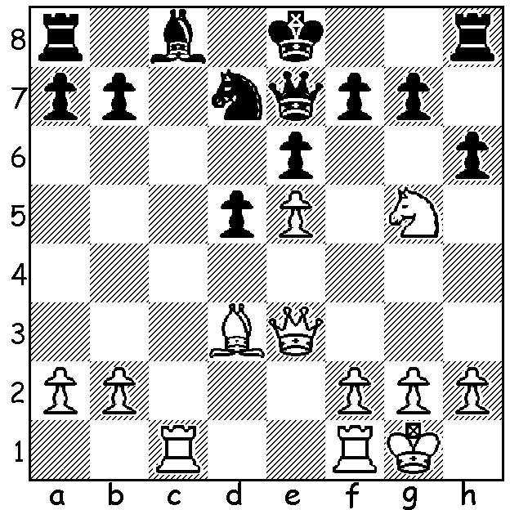
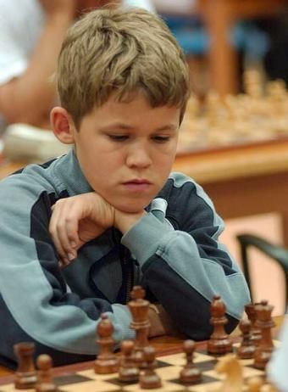
MAGNUS MAGIC
(vs Gustav Gulbrandsen 2002)
White to play and win
(5 moves): Magnus in his early days

WILL HE, WON’T HE?
Magnus Carlsen is due to defend his world championship title early next year but it remains uncertain whether he wishes to. He has cited lessening of the drive that has made him the number 1 player since 2011 (only Gary Kasparov has held the number 1 position longer). Let’s look at his amazing career so far. Born in 1990 in Norway, he showed genius potential from an early age. At two he could put together 50 piece jigsaws and at four could assemble lego sets intended for 10-14 year olds. He was coached at the Norwegian College of Elite Sport by the country’s top player GM Simen Agelstein and in one year, 2000, his rating leapt from 904 to 1907. He became the then youngest Grandmaster (GM) aged 13 years, 4 months and 26 days. He won the Norwegian championship when only 15 and his first major title, the prestigious Corus tournament at 17 (=1st). He defeated Viswanathan Anand for the world championship in 2013, a title he has held ever since. His rating peaked at 2882, the highest ever, in 2014 and 2019. (more next week).

The 2022 WA CHESS CHAMPIONSHIPS will be held from May 15 to July 3. See cawa.org.au for details.

SOLUTION: Black has an extra pawn (protected & passed) and after an expected knight retreat will castle and expect to win. However …. 1.Qxa7!! (deflection) 1...Rxa7 2.Rxc8+ Qd8 3.Rxd8+ Kxd8 4.Nxf7+ / 5.Nxh8. If 1...Rb8 2.Qxb8!! Nxb8 3.Rxc8+ Kd7 4.Rxh8 with two rooks and piece for queen. Such brilliance from an eleven year old!

