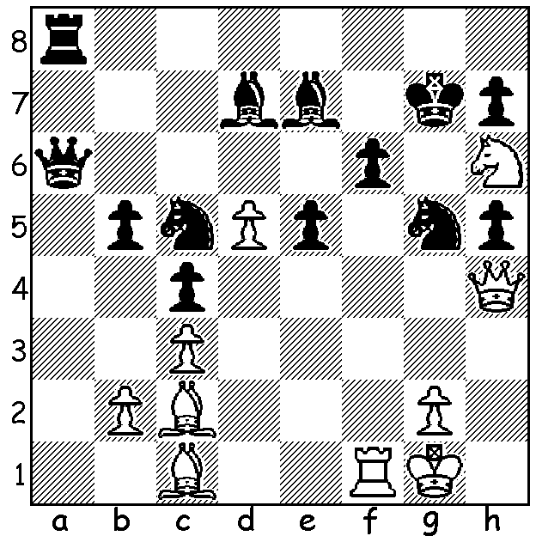
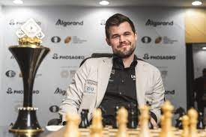
MORE MAGNUS MAGIC
Magdus Carlsen vs
Hans Harestad 2002:
White to play and win
(5 moves):

WILL HE, WON’T HE (2)?
As stated last week, Norwegian Magnus Carlsen is due to defend his world championship title early next year but it remains uncertain whether he wishes to. This week I shall concentrate on his matches since defeating then champion Indian Viswanathan Anand for the world championship in 2013 (6.5-3.5). Since then he has successfully defended his title against Anand in 2014 (6.5-4.5), against Russian Sergey Karjakin in 2016 (9-7), against American Fabiano Caruana in 2018 (9-6), and against Russian Ian Nepomniachtchi in 2021 (7.5-3.5). Rapidplay games decided the result against both Karjakin and Caruana after the matches were tied at 6-6 in Classic chess. Against Karjakin Carlsen lost Game 8 before winning game 10 and against Caruana all 12 games were drawn before Carlsen won three successive Rapidplay games. Carlsen has also been Rapidplay World Champion three times and Blitz World Champion five times. He has twice held all three titles in the same year.

The 2022 WA CHESS CHAMPIONSHIPS start tomorrow, May 15, at Leeming Primary and continue until July 3. Games begin at 1pm and spectators are welcome.

SOLUTION: At 13 Magnus unleashed 1.Qxg5+!! (deflection sacrifice) 1...fxg5 2.Rf7+ Kxh6 or Kh8 3.Rxh7#

