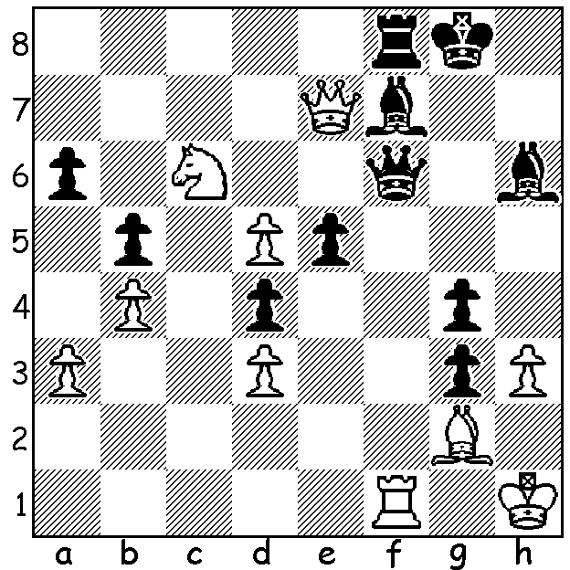
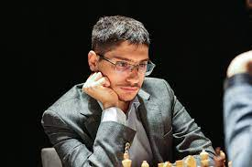
Alireza Firouzja
Oleg Papayan vs Alireza Firouzja, 2019:
Black to play and win (4 moves):

WHO WILL CHALLENGE MAGNUS?
The Candidates Tournament, with eight qualifiers and 14 rounds, starts on June 16 and finishes on July 5. Seeded second, the favourite to become the challenger for Magnus Caelsen’s world title, is Alireza Firouzja (born in 2003) who will become 19 during the event. Born in Iran, he began to play when eight and in 2015 won the Under 12 section of the Asian Youth championships. He won the Iranian Championship aged 12 (8/11, +5 =6) and became a Grandmaster (GM) at 14. He played for Iran in the 2016 and 2018 Olympiads scoring 4.5/8 and 8/11. In 2019 he announced he would no longer represent Iran because of the nation’s policy of not allowing its players to compete against Israeli players. That year he came second in the World Rapid Championship, a point behind world champion Magnus Carlsen. At the Chess24 online Banter Blitz Cup he defeated Carlsen 8.5-7.5 in the final. In 2021 Firouzja was granted French citizenship, and that year won the FIDE Grand Swiss Tournament with 8/11 and scored 8/9 competing for France in the European Championship, a performance rating of over 3000. His rating climbed to over 2800, making him the youngest ever to reach that number, breaking the record of Carlsen. After successfully defending his title against Ian Nepomniachtchi, Carlsen announced, “If someone other than Firouzja wins the Candidates, it is unlikely that I will play the next World Championship match”.

SOLUTION: 1...Qxf1+! (defection sacrifice) 2.Bxf1 Bxd5+ 3.Kg1 Be3+ 4.Kh1 Rxf1# or 3.Bg2 Rf1#.

