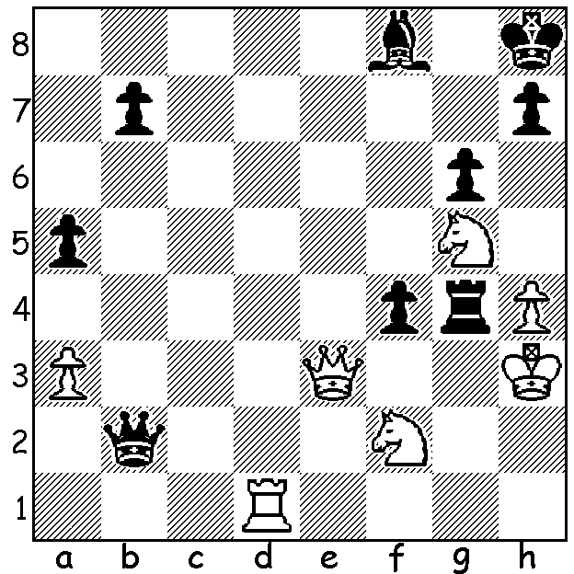
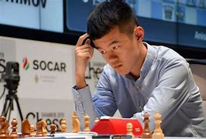
Ding Liren vs Rui Gao, 2014: Ding Liren
White to play and win (5 moves):

WHO WILL CHALLENGE MAGNUS? (2)
The Candidates Tournament, with eight qualifiers and 14 rounds, starts on June 16 and finishes on July 5. Top seed is Chinese GM Ding Liren who had a somewhat fortunate although deserved path to selection. Although China’s covid policy prevented him from participating in international events to win selection, the disqualification of Sergey Karjakin for expressing support for the invasion of Ukraine led to Ding being invited to take the Russian’s place with the proviso Ding meet the requirement of 30 Classic games dating from June 2021. Having only played four games, matches and mini-tournaments were arranged by China enabling Ding to play 28 games before the end of May. With his score of 20.5/28 (no losses), he overtook Firouzja as the second highest player behind Carlsen.
Ding was born in 1992, has been Chinese champion three times, has played for China in four Olympiads, winning two team gold medals and one individual gold (Bd 1). He defeated Maxime Vachier-Lagrave to win the final of the 2019 Grand Chess Tour and also won the 2019 Sinquefield Cup. Between August 2017 and November 2018 he was unbeaten in 100 consecutive games of Classic chess, a record until Carlson went 125 Classic games undefeated.

SOLUTION: 1.Rd8!! if 1...fxe3 2.Rxf8+ Kg7 3.Ne6+ Kh6 4.Nxg4+ Kh5 5.Nf4#.

