
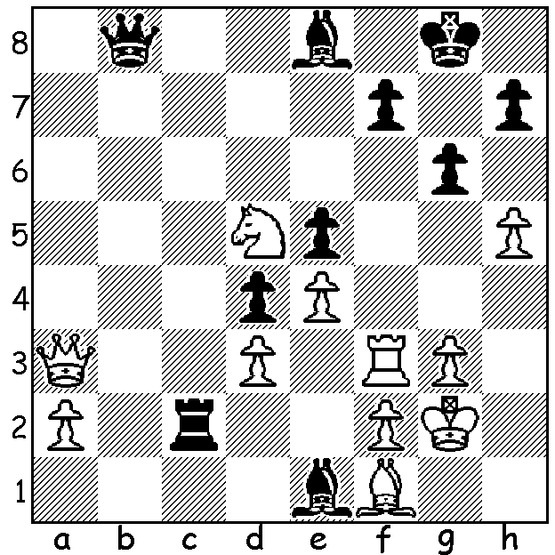

Fabiana Caruana vs Anish Giri, 2014 Fabiano Caruana
White mates in 5:

WHO WILL CHALLENGE MAGNUS? (3)
The Candidates Tournament, with eight qualifiers and 14 rounds, starts on June 16 and finishes on July 5. Third highest rated player is American Fabiano Caruana, aged 29, who will be playing his fourth consecutive Candidates and who finished in top place in 2018 before losing to Carlsen in his challenge with all 12 Classic games drawn before Carlsen won the Rapidplay tiebreak 3-0.
Caruana became a Grandmaster just shy of his 14th birthday. Born in Miami, he moved to Italy in 2005 and won the Italian Championship four times. Perhaps his greatest success was the 2014 Sinquefield in which he recorded a tournament rating of 3098, the highest ever. He moved back to America in 2015 with more notable successes coming his way including the 2016 US Championship, 2017 London Classic, 6th Norway Chess 2017 and Tata Steel 2020.


Highest rated Candidates qualifier Ding Liren recently
got in some rapidplay practice (15min + 10sec), winning
the online Chessable Masters, beating Carlsen 2.5-1.5 in
their semi final before defeating Praggnanandhaa in the
final which went to a blitz decider after each player had
won one four-game rapidplay set. A great achievement by
the 16 year old Indian (he had defeated Carlsen in the
Preliminaries) who combined chess with studying for and
taking some of his final school exams.

SOLUTION: 1.Nf6+ Kg7 2.h6+! Kxh6 3.Qf8+ Kg5 Ding and Pragg
4.Rf5+!! gxf5 5.Qg7#.

