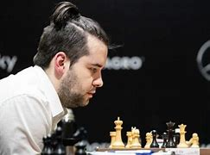
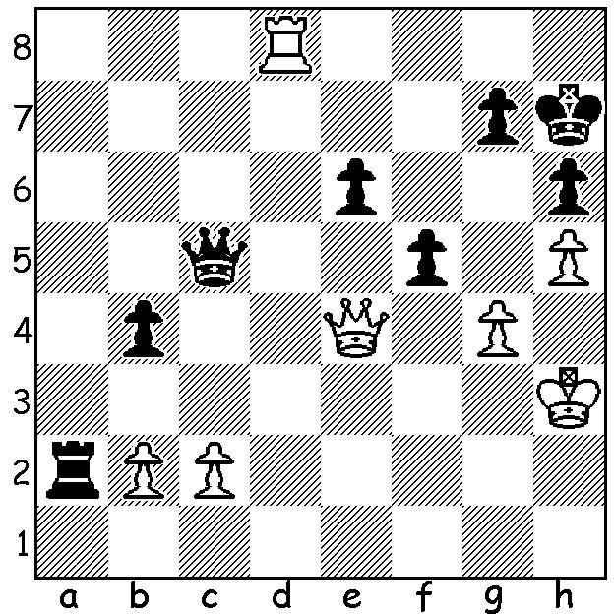
Ian Nepomniachtchi Ian Nepomniachtchi
vs Dmitry Bocharov 2008
White to play and win:

WHO WILL CHALLENGE MAGNUS? (4)
The Candidates Tournament, with eight qualifiers and 14 rounds, starts on June 16 and finishes on July 5. Fourth highest rated player (7th in world ratings) is Russian Ian Nepomniachtchi, who was the challenger to Magnus Carlsen in 2021. After five draws in the match Nepo lost the long sixth game despite having winning chances. He then collapsed scoring only two draws in the last five games and losing the match 3.5-7.5.
Born in 1990, Nepo learnt to play aged four and won many junior world titles. He became a Grandmaster in 2007. Important tournaments he has won include European Championship 2010, Russian Super Final 2010 & 2020, Aeroflot Open 2008 & 2015, Tal Memorial 2016, Candidates 2021. He has also won two silver medals at the World Rapid Championships and a silver in the World Blitz Championship.

AUSTRALIAN OLYMPIAD TEAM: The 2022 Olympiad will take place in Chennai, India, 28 July to 10 August (originally planned for Russia). As a selector for the Open team I was happy my choice was that of the overall selection committee: Temur Kuybokarov (aged 21, WA), Anton Smirnov (21), Justin Tan (25), Bobby Cheng (25), Zong-Yuan Zhao (35). This will be the first time Australia has fielded an all Grandmaster team.

SOLUTION: 1.g5!! and if 1...fxe4 2.g6# or 1...hxg 2.Qxe6 mating.

