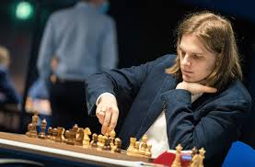
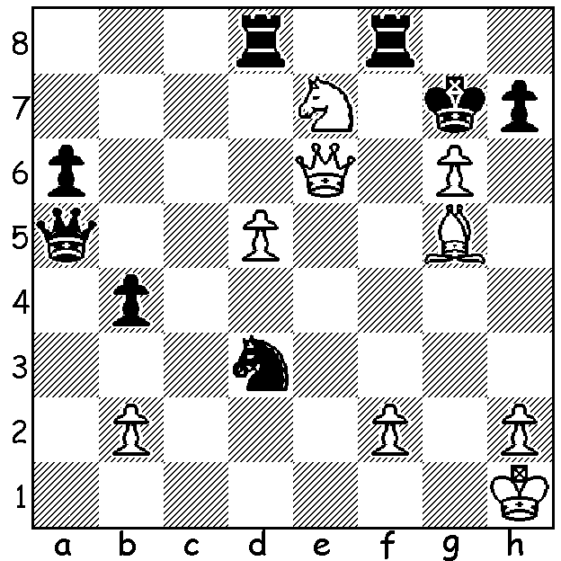
Richard Rapport
Richard Rapport vs Davor Rogic, 2010
White to play and mate in 6:

WHO WILL CHALLENGE MAGNUS? (5)

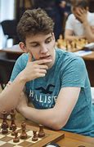
The Candidates Tournament, with eight qualifiers and 14 rounds,
started this week in Madrid. Fifth highest rated player (now 11th^{th} in
world ratings) is Hungarian Richard Rapport, at 26 the third youngest
entrant. He learnt chess from his father aged four and became a
Grandmaster just short of his fourteenth birthday. In 2017 he played
world champion Magnus Carlsen for the first time and won. He
qualified for the Candidates by reaching the semi-final of the 2021
FIDE Grand Prix and winning the second leg.

A little younger is Pole Jan-Krzysztof Duda at 24, who became
a Grandmaster soon after his 15th birthday. It was Duda who broke
Carlsen’s run of 125 unbeaten Classic games during the 2020
Altibox Norway tournament. His win in the 2021 World Cup, during
which he knocked out Carlsen, gained him qualification for the
Candidates. Jan-Krzysztof Duda

SOLUTION: 1.White, a rook down, now sacrifices his remaining bishop ro expose Black’s king further: 1.Bh6+!! Kxh6 2.gxh+ Kg5 (if 2...Kxh7 3.Qg6+ Kh8 4.Qh6#) 3.Qg6+ Kh4 (if 3…Kf4 4.Qg3+ Ke4 5.Qe3#) 4.h8=Q+! Rxh8 5.Nf5+ Kh3 6.Qg2/3#.

