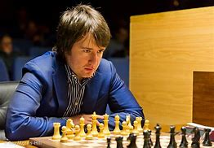
Teimour Radjabov vs Teimour Radjabov
Victor Jimenez 1998
White to play and win:

WHO WILL CHALLENGE MAGNUS? (7)
The final player to look at from the Candidates is world number 13 Teimour Rajabov, an Azerbaijani, born in 1987, and, like so many top Grandmasters, a former child genius. He became a GM aged 14 in 2001, at the time the youngest ever. His highest world ranking was 4 in 2012. He has played in two previous Candidates and also qualified for 2020 but withdrew because of concerns about Covid. He was given a wild card into this year’s Candidates. His most important tournament triumphs have been the winning of the 2008 Elista Grand Prix, the 2017 Geneva Grand Prix and the 2019 FIDE World Cup. He was the first player to defeat Kasparov after he had become world champion.
Ian Nepomniachtchi increased his lead to a point after 8 rounds when Fabiano Caruana lost to his American compatriot Hikaru Nakamura, a lead he maintained when he and Catuana drew in Rd 9.

The WA JUNIOR CHAMPIONSHIPS will be held from Monday 4th to Thursday 7th of July at the Sadler Centre, Corpus Christi College, Bateman. Competitions will be held for Under 8s, 10s, 12s and combined Under 14s, 16s & 18s. Check details on cawa.org.au

SOLUTION: 1.Ng5 Nf8 (defends against 2 mates) 2.Rf4 and Black is helpless; if 2...Rd8 3.Rh4 Rd1+ 4.Kh2 Rd4 5.Qxh7+! Nxh7 6.Rxh7#.

