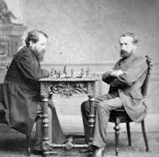
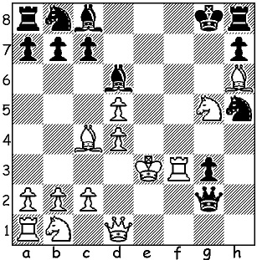

Wilhelm Steinitz vs Peter Wilson 1862 Steinitz Vs Zukertort (1896)
White has a quick mate

THE CHESS WORLD CHAMPIONSHIPS 1886-1993
The first World Championship was played in 1886 between Wilhelm Steinitz and Johannes Zukertort and from then until 1946 the champion set the terms for a challenge with the challenger required to raise a sizeable stake. Following the death of Alexander Alekhine, FIDE (Federation Internationale des Echecs), which had been founded in 1924, took over the organisation of the running of the championship, starting with a five player quintuple round-robin which was won by Mikhail Botvinnik. The world champion was then required to defend the title every three years against the qualifying challenger. This system continued until 1993 when the champion Garry Kasparov and his challenger Nigel Short broke away from FIDE over a dispute re the venue for their match with FIDE resuming control in 2006.

WA GRAND PRIX:
Note the following coming events:
17 July WA BLITZ, N Woodvale Prinary;
24 July WINTER RAPID, N Woodvale Primary;
30/31 S W OPEN at Matgaret River:
see details cawa.org.au

SOLUTION: 1.Rf8! Bxf8 2.d6+ Be6 3.Bxe6#. Played when Steinitz was still a romantic and had not established his revolutionary positional system.

