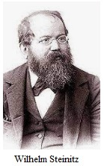
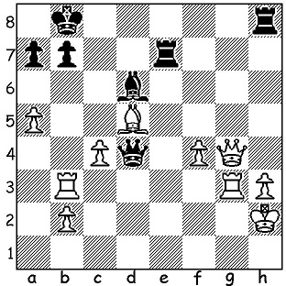

Wilhelm Steinitz vs Louis Paulsen 1882
White to play and mate.

WORLD CHAMPIONSHIPS (2)
Recognised as the first world champion, Prague born Wilhelm Steinitz (1836-1900), who had won the title in 1886 in USA against Johannes Zukertort from Poland 12.5-7.5, retained the title until 1894 (there is some thought he became champion when he beat the German Adolph Anderssen 8-6 (+8 =0 -6) in 1866. He defended his title twice, 1889 & 1892, against the Russian Mikhail Chigorin 10.5 -6.5 and 14.5-12.5 and in 1891 against the Hungarian Isidor Gunserg 10.5-8.5 (in matches the first to score 10 wins). His defeat came against the much younger Emanuel Lasker by 7-12 (+5 =4 -10). He then suffered a mental breakdown (as had Zukertort) and was placed in an institute before being released and again played Lasker. However he fared even worse losing 4.5-12.5 (+2 =5 -10). He continued playing until again institutionalised and died a pauper in NewYork.

The 2022 AUSTRALIAN CHAMPIONSHIP, held in the Gold Coast, was won by defending champion Temur Kuybokarov (WA) with 7/9. Close behind were Bobby Cheng (champions 2016) and Rishi Sardani on 6.5 and Zong-Yuan Zhao (champion 2010) on 6.

AUSTRALIAN OLYMPIAD APPEAL:
There is no Government assistance to our team competing in the Chess Olympiad in India starting this month with each player having to raise a substantial sum to participate. Please join me in assisting our team by contributing via acfappeal.aunz.org

WA GRAND PRIX:
Tomorrow 24 July, Winter Blitz at N Woodvale Primary and 30/31 July S W Open in Margaret Rive. See cawa.org.au

SOLUTION: 1.Qg8+! Rxg8 (1...Re8 2.Rxb7+ Kc8 3.Qg4+) 2.Rxg8+ Kc7 3.Rxb7#.

