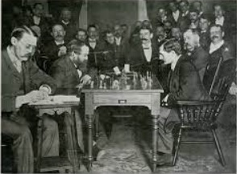
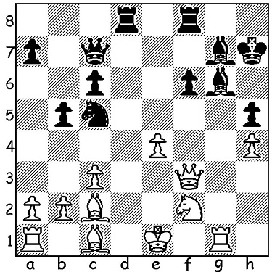
Steinitz Vs Lasker (1894)
Wilhelm Steinitz vs Emanuel Lasker 1894
White to play and win (4 moves)

WORLD CHAMPIONSHIPS (3)
World Champions 1886 - 1946
1886 - 1894 Wilhelm Steinitz
1894 – 1921 Emanuel Lasker
1921 – 1927 Jose Raul Capablanca
1927 – 1935 Alexander Alekhine
1935 – 1937 Max Euwe
1937 – 1946 Alexander Alekhine

2022 WEST AUSTRALIAN CHAMPIONSHIP
The 2022 West Australian Championship was completed recently with 2020 winner Patrick Gong, who remained undefeated with 5.5/8, winning the title from 2018 champion Stephanus Kurniawan on 5.
Winner of the Reserve Championship was relative newcomer Rui Gen Teh on 6/7 followed by David King on 5.

AUSTRALIAN OLYMPIAD APPEAL
There is no Government assistance to our team competing in the Chess Olympiad in India starting this month with each player having to raise a substantial sum to participate.
Please join me in assisting our team by contributing via acfappeal.aunz.org

SOLUTION
1.Rxg6! Kxg6 2.Qf5+ Kf7 3.Qxh5+ Ke6 4.Qxc5 & White has won B, N & p for R.

