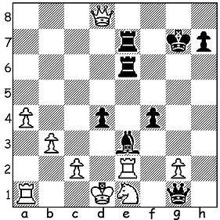
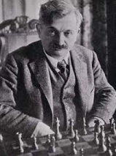

Siegbert Tarrasch vs Emanuel Lasker 1908 Emanuel Lasker
Black to play and win (very subtle):

WORLD CHAMPIONSHIPS HOLDERS - LASKER
Prussian Emanuel Lasker (1868-1941), world champion for 27 years, 1894 – 1921, lived in Germany, UK and USA. He defeated Wilhelm Steinitz -5 =10 -10 in 1894 to take the title and successfully defended the title against Steinitz in a second match, Mikhail Chigorin (Russia) in two matches, against Frank Marshall (USA), Siegberg Tarrasch (Germany) and David Janowski (Franco-Polish). He was finally beaten in 1921 in Cuba by Jose Raul Capablanca(Capablanca) 9-5 without winning a game. He retired from chess but returned due to financial problems, coming 1st in the great 1924 New York tournament ahead of Capablanca and future champion Alexander Alekhine (Russia). At 67 he came 2nd at 1924 Moscow, undefeated and half point behind Mikhail Bovvinnik (Russia) and Lazlo Flohr (Czech.), an amazing feat aged 67.

The 2022 AUSTRALIAN CHAMPIONSHIP,
held in the Gold Coast, was won by defending champion Temur Kuybokarov (WA) with 7/9. Close behind were Bobby Cheng (champions 2016) and Rishi Sardani on 6.5 and Zong-Yuan Zhao (champion 2010) on 6.

AUSTRALIAN OLYMPIAD APPEAL:
There is no Government assistance to our team competing in the Chess Olympiad in India starting this month with each player having to raise a substantial sum to participate. Please join me in assisting our team by contributing via acfappeal.aunz.org

SOLUTION:
Black activates his bishop with the clearance sacrifice 1..f3!! If 2.gxf Bg5! 3.Rxe6 Rxe6 and a White check is parried by 4...Re7 while 4.Qa5 loses to 4...Bh4.

