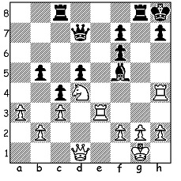
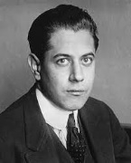

Jose Raul Capablanca

Jose Raul Capablanca vs Harry Morris 1911
White to play and win:

WORLD CHAMPIONSHIP WINNERS, CAPABLANCA
Considered by many as the most natural player of all time, Jose Raul Capablanca (1884 – 1942) learnt to play chess at the age of four watching his father play. It’s said that young Raul set up a position from a game the previous night and showed his father how he could have won. Capablanca, born in Cuba, moved to study at Columbia University, USA. During that time he played a match against the top American player Frank Marshall (a challenger to world champion Emanuel Lasker) which the young Cuban won +8 =14 -1.
This was the springboard to invitations to play in the leading tournaments around the world, the first being 1911 San Sebastian where he came first although many had decried his invitation due to inexperience, He followed this with second to world champion Emanuel Lasker at 1914 St Petersburg. He challenged Lasker and took the world title in 1921 in Havana +4 =14 -0. After a number of tournament successes he faced a challenge from Alexander Alekhine to be played in Buenos Aries with Alekhine having to raise $10,000. Although the underdog, Alekhine won the match 18.5-15.5 (+3 =25 -6). Capablanca was never granted a return match with Alekhine and he died in 1942 after a heart attack at the Manhattan Chess Club.

SOLUTION:
1.Re7!! (deflection) 1...Qxe7 2.Nxf5 and if 2...Qe6 3.Rxh7+! Kxh7 4,Qh5#.

