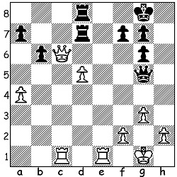
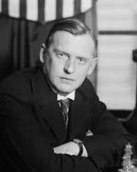

Alexander Alekhine vs Edgar Colle 1925 Alexander Alekhine
White to play and win:

WORLD CHAMPIONSHIP WINNERS, ALEKHINE (I)
Born in Moscow in 1892, Alexander Alekhine was the first world champion to win, lose and regain the title as well as the one and only to die while still champion. He started playing tournaments in his teens and sought to choose his openings and style to emulate Mikhail Chigorin, Russia’s most famous player, who had played two close world championship matches against Wilhelm Steinitz. From 1912, when he was 20, he regularly began to win events, including equal first in the 1914 All-Russian championship with Aaron Nimzovitsch. World War I broke out while he was playing in Mannheim and he, together with a number of other players, was interred in Germany. However family influence secured his release and he went on to serve on the front in the Red Cross where he was wounded. He won the Soviet championship in 1920 but then emigrated, moving to France and deserting his wife. Then, after a string of tournament successes, he secured a match with champion Jose Raul Capablanca and, despite being given very little chance, won the match 18.5-15.5 (+6 =25 -3). However, despite the closeness of the score, Alekhine refused to accept a rematch (to be continued).

SOLUTION:
1.Qxd7! Rxd7 2.Re8+ Kh7 3.Rcc8 and Black can only prevent Rh8# with ...Qc1+.

