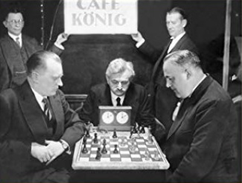
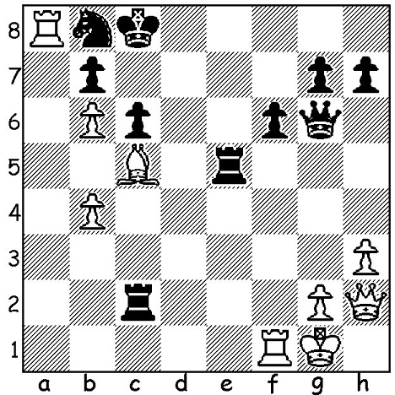
Alexander Alekhine vs Samuel Reshevsky 1937 Alekhine V Bogoljubov
White to play and win: 1929 World Championship Match

WORLD CHAMPIONSHIP WINNERS, ALEKHINE (2)
After defeating previous champion Jose Raul Capablanca 18.5-15.5 in 1927 in Buenos Aries, Alexander Alekhine avoided a rematch, instead twice defeating Russian/German Efim Bogoljubov 15.5-9.5 and 15.5-10.5. However Alekhine always a hard drinker, began to drink more and more heavily which had an effect on his play and contributed to his loss in his next defence, against a Dutch school teacher Max Euwe. The match was played in various cities and towns in the Netherlands in 1935 resulting, in a win for Euwe 15.5-14.5 (+9 =13 -8). Euwe didn’t follow the example of Alekhine who had avoided a rematch with Capablanca but played a return match in 1937. Alekhine meanwhile had severely moderated his drinking habits and defeated Euwe 15.5-9.5 (+10 =11 -4). Alekhine began World War II as a fervent patriot while France was undefeated but became a collaborator on its defeat, responsible for a number of anti-Semitic publications. He lived in Spain and Portugal the after the war and died aged 54 while in the midst of seeking help from the British Chess Federation to arrange a world championship match against the leading Russian Mikhail Botvinnik. After Alekhine’s death the World Chess Federation (FIDE) took over the running of the world championship and has continued to ever since apart from 1993 to 2006.

SOLUTION:
1.Rxb8+! Kxb8 2.Qxe5+! fxe5 3.Rf8 mating.

