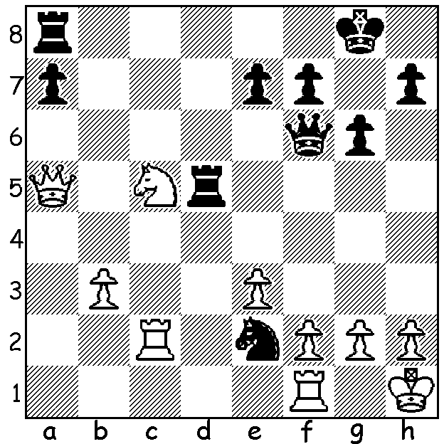
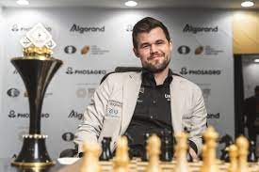
Magnus Carlsen
Wesley So vs Magnus Carlsen 2017
Black mates quickly:

MAGNUS ANNOUNCES HE WILL NOT DEFEND TITLE
Having been away for seven weeks I’ll be catching up on some important chess news. Firstly the announcement by world champion Magnus Carlsen that he will not be defending the title against
Ian Nepomniachtchi who won the 2022 Candidates undefeated with a round to spare, scoring 9.5/14. Carlsen had beaten Nepo comfortably by 7.5-3.5 in his last defence and had said before the Candidates that he would probably only defend the title against one of the younger of the competitors, probably Aliireza Firouzja. However Firouzja only finished 6th of 8 players with 6/14 while the other two young players fared even worse with Jan-Krzszytof and Richard Rapport both scoring 5.5. However there will be a world championship match with the Russian Nepomniachtchi playing Candidates runner-up Ding Liren (China) who scored 8/14. Despite giving up the world title Magnus will continue to take part in tournaments.

The WILLETTON OPEN (WA GP event) will be played 17 & 18 September at Leeming Primary. Check cawa.com.au for details or contact me on ellisd19@bigpond.com or 0439798607.

SOLUTION: 1...Qxf2! 2.Qe1 (2.Rxf2 Rd1+ mating) 2...Ng3+! 3.hxg3 Rh5#.

