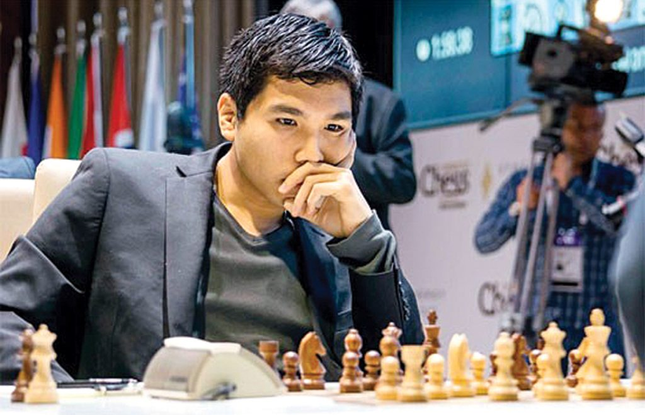
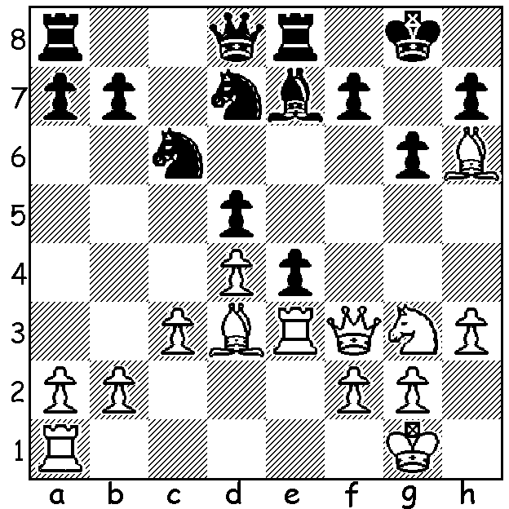
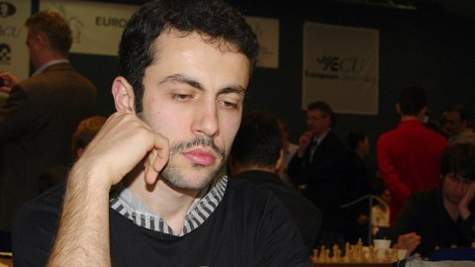
Wesley So (USA) vs Hrant Mulkumyan (Armenia):
Olympiad 2022
A brilliantly analysed series of sacrifices by White leads to mate.
So (top) & Mulkumyan
CHESS OLYMPIAD 2022
The other major chess news while I was out of the country was the 44th Olympiad played in Chennai, India, from 28 July to 9 August. 350 teams competed in the combined Open and Women’s events with teams consisting of four players and a reserve. In the Open, with the non-participation of China and Russia, USA was ranked first with India A second in. However winner was Uzbekistan on tie-break from Armenia after both teams finished on 19 match points in their 11 matches (2 points win, 1 point draw). India B was 3rd (18) with India A, USA, Moldavia 4th-6th. Australia was 30th with 14/22. Women’s - 1st Ukraine 18/22 on tie-break from Georgia, 3rd India (17) with Australia, 42nd with 13 in a cluster of teams 35th – 52nd,.

The WILLETTON OPEN (WA GP event) will be played 17 & 18 September at Leeming Primary. Check cawa.com.au for details or contact me on ellisd19@bigpond.com or 0439798607.

SOLUTION: After Black’s ...e4 White unleashed 1.Rxe4!! and if 1.dxe4 2.Qxf7+!! Kxf7 3.Bc4+ Kf6 4.Nxe4+ Kf5 5.g4+! Kxe4 6.Re1+ Kf3 7.Bd5# ot Re3#. Black now saw the mate and played 1...Nf8 but a pawn down and facing a winning attack Black soon resigned.

