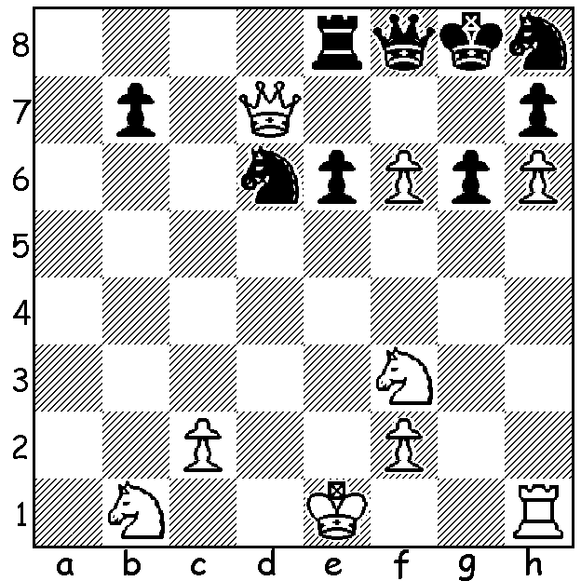

David Navara (Czech.) vs Dambasuren Batsuren (Mongolia),
Olympiad 2022: Can you find White’s quickest win?

INDIAN YOUNG BRIGADE STAR
A further look at the Olympiad results with firstly results of the phenomenal performance by India B, a team of young players with an average age of less than 20. They finished on 18/22, only one point behind winners Uzbekistan and runners-up Armenia and one point ahead of India A with Dommaraju Gulesh winning Bd 1 individual gold, Nihal Sarin Bd 2 gold.
Perhaps the biggest surprise was the relative failure of defending champions USA who, despite this time having former Armenian star Levon Aronian, could only manage fifth with 17.
Australia was in a group of 18 teams on 14, placed 30th in the 186 field. Individual scores (in board order): Anton Smrinov 3/9 (+1 =4 -4, a disappointing result after excellent scores in the two previous Olympiads), WA’s Temur Kuybokarov 6/9 (+4 =4 -1, an excellent result), Bobby Cheng 8/10 (+7 =2 -1, an even better result), Justin Tan 5/8 (+4 =2 -2), Zhao ZongYuan also 5/8 (+4 =2 -2).
In the Women’s event Australia’s team (Julia Ryjanova 6.5/10, Jiln Zhang 5.5/9, Heather Richards 3.5/8, Phan Nguyen Mai Chai 4.5/8 and Nguyen Thu Giang 6/9) came 42/159 with 13/22.

The WILLETTON OPEN (WA GP event) will be played this Saturday and Sunday at Leeming Primary. Check cawa.com.au for details or contact me on ellisd19@bigpond.com or 0439798607. Entries accepted up to 9.45

SOLUTION: 1.Qxh7!! Kxh7 2.Ng5+ Kg8 3.h7#. The Czech top board scored a fine 7/10, losing only in the final round.

