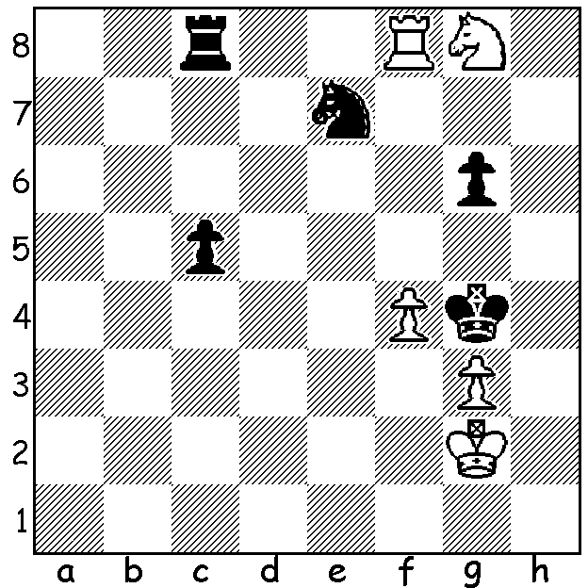
Puzzle origin unknown:
the position seems headed for a draw,
but White pulls off an amazing win
(after the fireworks there are still
problems for White):

MAGNUS WITHDRAWS DURING TOURNAMENT
After voluntarily relinquishing the world title Magnus Carlsen has become embroiled in a controversy after withdrawing during a tournament. He had gone 53 Classic games without loss and had in July won the Super United Rapid and Blitz in Zagreb, Croatia, (runner-up Maxime Vachier-Lagrave). However after his loss to 19 year American Hans Niemann in Rd 3 of the prestigious Sinquefield Cup in St Louis, Magnus withdrew from the event. His withdrawal was seen as an oblique accusation of cheating by his opponent. The tournament committee cleared Niemann but speculation has been rife, especially as he has a record of cheating when both 12 and 16 at online chess. The accusation clearly effected his play and he failed to win another game. Winner of the event was 20 year old Alireza Firouzja whom Carlsen had wanted to play a title match against. Firouzja won the event with victory in a play-off against Ian Nepomniachtchi, Carlsen’s last challenger who had qualified to challenge Carlsen a second time. Firouzja had also won the preceding St Louis Rapid and Blitz with Hikaru Nakamura second (Carlsen had not entered). This week when again facing Niemann, Carlsen, who was leading the Julius Baer Rapid & Blitz event, again shocked the chess world by resigning on the 2nd move. The mystery continues.
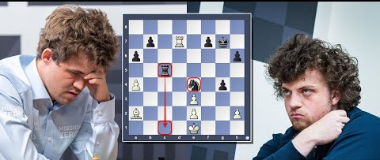
Magnus Carlsen Hans Niemann

SOLUTION: 1.Rf5!!! if 1...gxf5 2.Nf6#, if 1...Nxf5 2.Rxc8, if 1...R/Nxg8 2.Rg5#: Black’s best is 1...Kxf5 and now White has to walk the tightrope with intricate knight manoeuvres after 2.Nxe7+
a) 2...Ke6 3.Nxc8 3.c4 4.Na7 c3 5.Nb5 c2 6.Nd4+ or b) 2...Kg4 3.Nxc8 c4 4.Nd6 c3 5.Nc4 c2 6.Ne3+.

