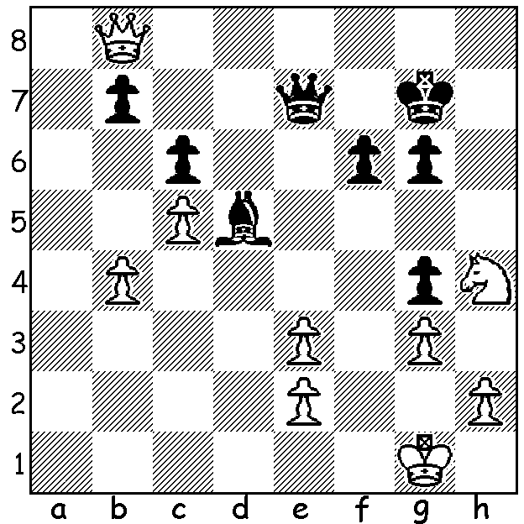

David Ellis vs
Pat Halpin
(Australian
Championahip 1977)
Black’s last move, ..Bd5,
gives White an unexpected
winning opportunity:

2023 AUSTRALIAN OPEN IN PERTH
When I returned from holiday last month I discovered that the WA Chess Association had its bid to hold the Australian Open Championship in Perth endorsed by the Australian Chess Federation. The tournament will be held next January over 11 rounds from 2nd to 10^{tth} at the Rendezvous Hotel in Scarborough. Besides the Open there will be a Minor Championship, open to players with a rating below 1500 FIDE (or 1600 ACF if without a FIDE rating). It is hoped there will be a large WA contingent playing especially as the yearly alternating Australian Open and the Australian Championship (a tournament solely for Australians, needing qualification through rating, being a state champion or Australian Junior champion) only get to Perth occasionally. By my recollection the last Australian Championship in Perth was in 1977-78 and the last Australian Open in Perth in 1988-89. (Tournaments used to be played from the last few days of December into the second week of January. My first Australian Championship in 1972-73 lasted 15 rounds.) The Open defending champion is 22 year old West Australian Temur Kuybokarov who won the Open in 2019 (no event 2021) as well as the Australian Championship in both 2020 and 2022. Check out details on cawa.org.au and arrange leave if necessary. Don’t miss out on a chance to play in one of Australia’s most prestigious events!


The 2022 SPRING ALLEGRO (WA GP) will take
place on Sunday 9 October at the St George Hotel,
2 Morris Rd, Innaloo . Check cawa.com.au for details.

SOLUTION: 1.Qh8+!! Kxh8 2.Nxg6+/3.Nxe7 & wins.
The game went 1...Kf7 2.Qh7+ Ke6 3.Qxe7+ Kxe7 4.Nxg6+
& wins. With the bishop on e6 the combination would fail
with the knight getting trapped on e7. Alexander Alekhine
missed this combination in a World Championship match
against Max Euwe in the 1930s.

Temur Kuybokarov

