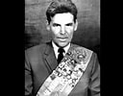
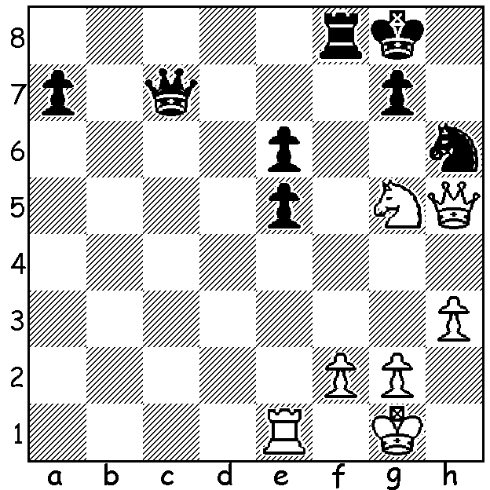
Rashid Nezhmetdinov vs Yuri Zelinsky 1954: White to play and win (5 moves):

CHESS CHEATING CHATTER

A fortnight ago I described the circumstances of the withdrawal by world champion Magnus Carlsen against 19 year old Hans Niemann in the Sinquefield Cup being played in St Louis
with the veiled hint of cheating after Niemann’s win. FIDE (International Chess Federation)
rebuked Carlsen for his withdrawal but nevertheless announced an investigation with a three

person panel and tightened security.
When Carlsen next came up against
Niemann he resigned on his second
move but still went on to win the
tournament,the online Julius Baer
Generation Cup. Carlsen was much
more explicit later in a published
statement: “I believe that cheating
is a big deal and an existential threat
to the game….I believe Niemann has
cheated more – and more recently –
than he has publicly admitted. I am Niemann Carlsen
not willing to play chess with Niemann. I hope that the truth on this matter comes out, whatever it is.” Niemann had admitted cheating while playing online chess when 12 and 16 and had been twice banned by Chess.com, a leading online chess company. Chess Grandmasters and commentators have been split on the issue with some defending Niemann and others believing there may be truth in Carlsen’s accusations. More later..

The 2022 SPRING ALLEGRO (WA GP) will take place on Sunday 9 October at the St George Hotel, 2 Morris Rd, Innaloo . Check cawa.com.au for details.

SOLUTION: 1.Qg6 Rf6 (forced) 2.Qd8+ Rf8 3.Qxf8+! Kxf8 4.Nxe6+ / 5.Nxc7. Similar combination to last week but with two preparatory moves. Expect to hear more of Nezmetdinov in the future.

