
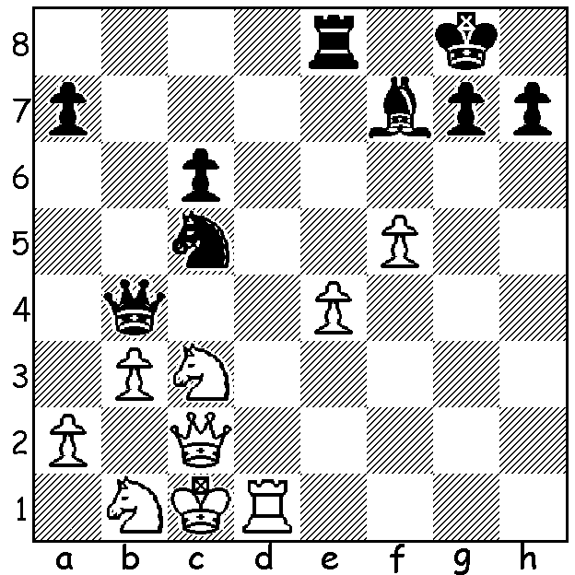
Gunnar Usi vs Rashid Nezhmetdinov 1955: Black to play and win (5 moves):

CHESS CHEATING (cont)
Continuing the saga of the accusations of cheating levelled at 19 year old Hans Niemann by world champion Magnus Carlsen, I’ll refer to chess.com statements about Niemann and cheating. In a 72 page report containing a host of statistics chess.com claimed Niemann ‘has likely cheated in more than 100 online games, including several prize money events.’ It banned Niemann after his victory over the board win against Carlsen at the Sinquefield Cup last month. It did this before the start of its 64 player Global Chess Championship with prize money of US$1 million. It had also previously banned him in 2020. One might ask how could chess.com be sure there had been cheating. With many events online being played at faster time limits than classic rates, players will play less well and they will play moves considered inferior by engines. If a player makes best moves consistently (and especially in crucial complex positions) it strongly suggests that player is receiving engine
assistance. There is also the fact that Niemann has admitted to cheating on a couple of occasions. Also creating strong suspicion is his rating improvement in two years, called ‘statistically
extraordinary’ by chess.com, which saw him move from about 800th to be in the top 50 with his rise faster than anyone else at a comparable age, including Bobby Fischer. Next week his performance in the over-the-board US Championship.

The SAINT BLITZ TOURNAMENT will be played Sunday 23 October at the St George Hotel, 2 Morris Rd, Innaloo. Contact Andrew Hardegan 0407 421 084 or andrewhardegen@iinet.au

SOLUTION: 1...Bxb3! 2.axb3 Nxb3+ 3.Kb2 Nd4+ wins queen: if 2.Qb2 Rb8 3.axb3 Nxb3+ 4.Kc2 Nd4+ again winning queen.

