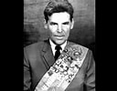
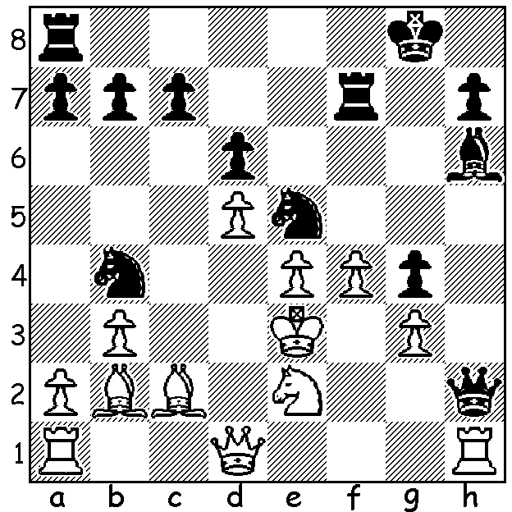
Lev Polugaevsky vs Rashid Nezhmetdinov 1958: Black to play and win:

A FEARSOME ATTACKER
As the US Championship is at time of writing unfinished, here is the promised article on Rashid Nezhmetdinov. Born in 1912 in Kazakhstan, Nezhmetdinov, a Tartar, was raised in abject poverty with his parents dying early from overwork. He was saved from starvation (a fate that befell thousands of children at that time) by his brother who had him admitted to an orphanage. He first gained success in Draughts before switching to Chess after a bout of illness allowed him to study Chess in hospital. His greatest success was in the 1954 Bucharest International, one of the three times he was allowed out of the USSR. He came into the last round equal first with Viktor Korchnoi, but lost to Semyon Furman, finishing second on 12.5/17. He was also second (behind Mark Taimanov) in the 1961 Chigorin Memorial. He won the Championship of the Russian Federation five times and competed in a number of USSR championships, winning the Best Game prize for his win over Mikhail Tal in 1961. Other top players he defeated include Boris Spassky, David Bronstein, Lev Polugaevsky and Efim Geller. Dying in 1974, having never attaining the rank of Grandmaster, he nevertheless left a legacy of brilliant attacking victories.

The SAINT BLITZ TOURNAMENT will be played tomorrow, Sunday 23 October, at the St George Hotel, 2 Morris Rd, Innaloo. Contact Andrew Hardegan 0407 421 084 or andrewhardegen@iinet.au

SOLUTION: Rxf4!!! The game went 2.Rxh2 (2.gxf4 Bxf4+! 3.Nxf4 Nxc2+ wins) 2...Rf3+ 3.Kd4 Bg7! 4.a4 (prevents 4...b4) 4...c5+ 5.dxc6 bxc 6.Bd3 Nexd3+ 7.Kc4 d5+ 8.exd5 cxd5+ 9.Kb5 Rb8+ 10.Ka5 Nc6+ White resigns (choice of three mates after 11.Ka6). This game appears in The World’s Greatest Chess Games (Burgess, Nunn, Emms 1998).

