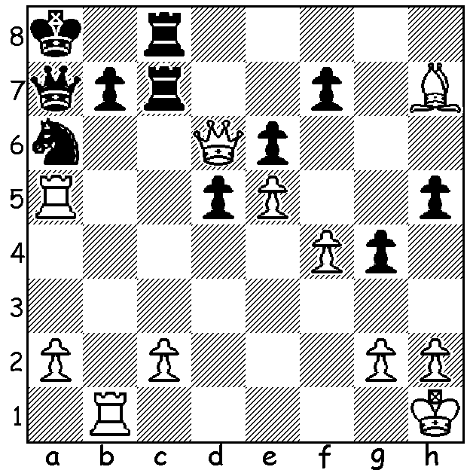

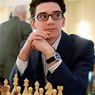
Fabiano Caruana vs Fabiano Caruana
Nikita Vitiugov 2012
White to play and win:

US CHAMPIONSHIP
The US Championship, a 14 player 13 round tournament, was played between October 5th to 18th. Winner was Fabiano Caruana with 8.5/13 (+4 =9), a half point ahead of Ray Robson, who was also unbeaten and attained the 2700+ Super GM rating. Caruana, who had played Magnus Carlsen for the world title in 2018, losing 0-3 in a play-off after a drawn 6-6 match, had also won the US title in 2016. Other previous champions fared less well – So, champion 2017, 2022, 2021, Sam Shankland, champion 2018, both scored 7. Notable absentee was 5 times champion Hikaru Nakamura. Hans Niemann, who came under extreme scrutiny during the event after cheating allegations, scored 7, while Levon Aronian, formerly Armenia, only managed 6. Seven players, half the field, went through unbeaten.
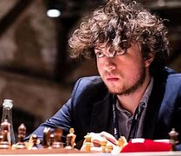
Niemann is suing world champion Carlson for
$US100 million, claiming Carlsen defamed him by
accusing him of of cheating. He is also suing chess.com
which claimed he cheated in at least 100 online games
and banned him from playing on its site.

The KINGSLEY OPEN, 12-13 November at N Woodvale
Primary, will be the next WA GP event. See cawa.org.au,
contact Dylan Gough chessnut36@gmail.com or 0402 747 737.

SOLUTION: 1.Rb6 (threat 2.Rxa6! bxa6 3.Rxa6) 1...Rc6
2.Raxa6! wins (if 2...bxa6 3.Rxc6 or 2...Rxd6 3.Rxa7+ Kxa7 4.Rxd6). Hans Niemann

