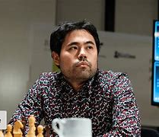
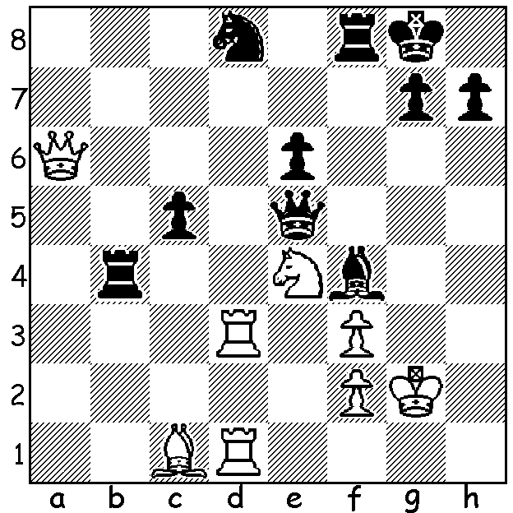
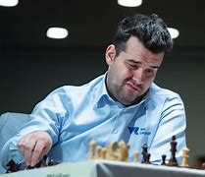
Ian Nepomniachtchi vs Hikaru Nakamura,
Fischer Random World Championship Final, Game 1: Black to play and win:

NAKAMURA Chess 960 WORLD CHAMPION
The Fischer Random World Championship (also called Chess96) was held fittingly in
Reykjavik, Iceland, where Bobby Fischer defeated Boris Spassky for the world title and where he is buried. Chess960 refers to the number of random starting positions possible (pawns in their usual place). As in normal chess identical pieces are opposite each other (eg king opposite king) and
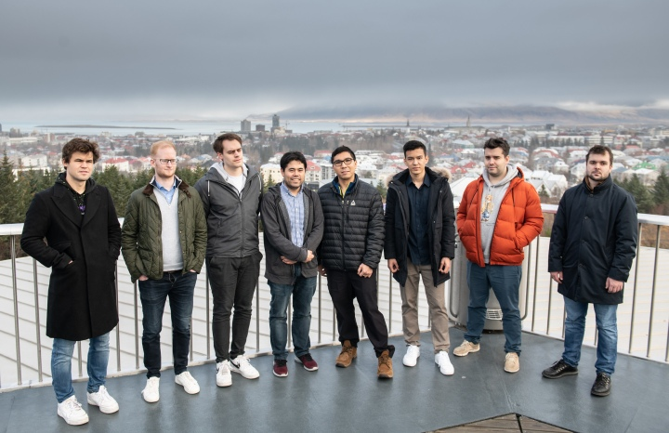
castling is allowed subject to normal rules.Time limits were 25 min each followed by 5 min with 5 sec increments. Four invitees (winner of previous championship Wesley So, his runner-up Magnus Carlsen, FIDE's president's choice Ian Nepomniachtchi and Icelandic champion Hjorvar Gretarsson) were joined by four qualifiers. Contestants were split into two groups to play each opponent twice with the top two from each group going into four knock-out mini-matches where Nepomniachtchi defeated Carlsen 3-1 after losing the first game and Hikaru Nakamura defeated teenage sensation from Uzbekistan world Rapid champion Nodirbek Abdusattorov 3-0. After four games the final was locked 2-2 with one win and two draws each. The Armegedden game gave White 15 mins with the player bidding the lower time selected as Black. With Black Nakamura only needed a draw but he managed to defeat Nepo in a tense game to win the title.
Contestants (how many can you name?)

The KINGSLEY OPEN, 12-13 November at N Woodvale Primary, will be the next WA GP event. See cawa.org.au, contact Dylan Gough chessnut36@gmail.com or 0402 747 737.

SOLUTION: 1...Rxe4! - this wins a piece: 2.fxe4 Bxc1 3.Rxd8 (3.Rxd1 Qg5+) 3...Qg5+: if 2.Bxf4 Rexe4 3.Rxd8 Qg5+).
Contestants: I could only name four: 1.Carlsen, 4.Nakamura, 5.So, 7.Nepo.

