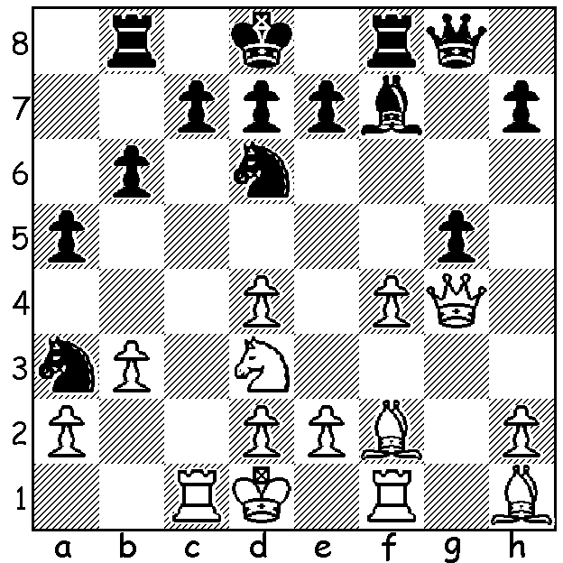
Looking at this diagram you would find it hard to believethat the two players were the world champion Magnus Carlsen and his most recent challenger Ian Nepomniachtchi. However the strange
positioning of the pieces reveal it is a Fischer Random game. It was played last month in Reyjkavik in the semi-final of the World Fischer Random Championship where Nepomniachtchi defeated Carlsen to reach the final before losing to Hikaru Nakamura. However Carlsen (Black) drew first blood in the semi with a brilliant mating attack which included an initial discoverd attack and breakthrough sacrifice followed by a deflection sacrifice and finally an obstruction sacrifice, mating in 7 moves.
SUCCESS FOR AUSTRALIAN JUNIORS
For the first time since 1988, when Shane Hill won the Under 20 title, a young Australian has won an Asian junior title. Ryeyanish Annapureddy from Melbourne won the gold medal in the Under 8s at the Asian Youth Championships held in Bali, 13-22 October with over 400 entries. Perth's Rebo Fu also came away with a medal after coming third in the Under 16s. The leading countries overall were India and Vietnam winning a stack of medals in the Classic, Rapid and Blitz events.

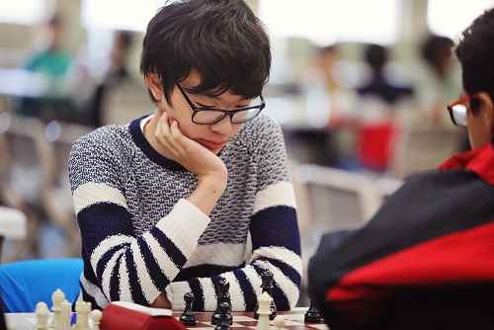

Reyanish Annapureddy Rebo Fu

SOLUTION: 1...Bxb3+! (activating the f8 rook) 2.axb3 Rxf4!! (deflecting the knight) 3.Nxf4
(declining the sacrifice leads to fatal material loss) 3...Qxb3+ 4.Ke1 Nc2+ 5.Kd1 (if 5.Rxc2 Qb1+ 6.Rc1 Qxc1#) 5... Ne3+ 6.Ke1 Qd1+! 7.Rxd1 Nc2# . What a finish!

