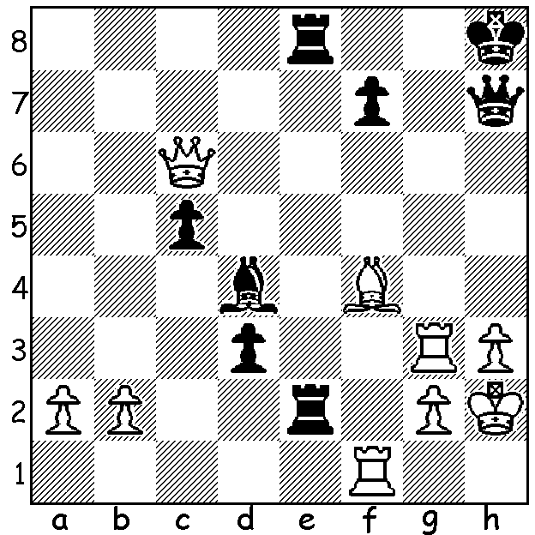
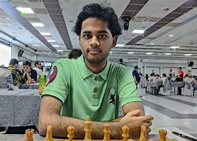
Arjun Erigaisi - Shakhriyar Mamedyarov (Meltwater Tour Final 2022)
White to play and win; can you name the combinative idea?

MAGNUS STILL HAS WILL TO WIN
The 2022 Meltwater Champions Chess Tour is a nine month series of online rapidplay tournaments with a prize pool of US$1.6 million. The final event with eight contestants playing each other in a series of 4 game mini matches (time control 15 mins + 10 sec each move) finished earlier this month with retired world champion Magnus Carlsen (Norway) a comprehensive winner (+16 =9 -2). He won every match with only Le Quang Liem (Vietnam) beating him before losing an Armegeddon decider. Wesley So (US), the 2021 winner, who lost two matches, was a distant second with Jan-Krzysztof Duda (Poland) third.

SOLUTION: 1.Be5+! wins: if 1...either Rxe5 2.Qf6+ Qg7 3.Qxg7# & if 1.Bxe5 2.Qxe8+ Qg8 3.Qxg8#. An attractive example of an interference or obstruction sacrifice wth a rook obstructing
the diagonal of the bishop guarding f6 or the bishop interfering with e2 rook's defence of the e8 rook. Winner 19 year old Arjun Erigaisi became a Grandmaster at 14 and is the current Indian champion.

