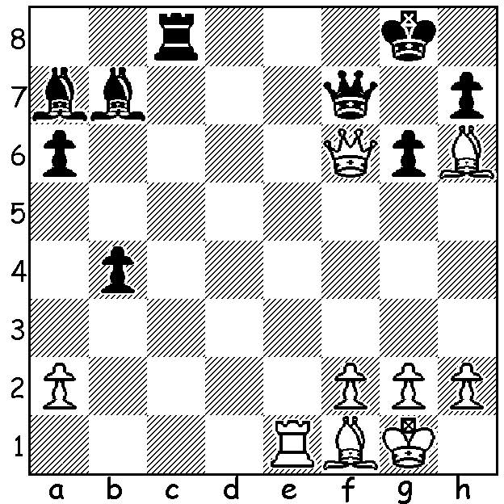
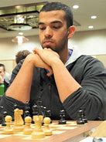
Daniel Fernandez vs James Jackson
(British Championship 2014)
White unleashes a sparkling mating combination Daniel Fernandez
(3/4 moves)

YOUR STATE NEEDS YOU!
The 2023 Australian Championship (11 rounds) will be held from 2 - 10 January at the Rendevous Hotel, Scarborough. There will be an Open section which so far has 68 entries and a Minor section with 26 players with players needing to be rated under 1600 ACF or 1500 FIDE. Concessional entry fees are available until December 12 so take advantage of this opportunity to take part in Australia's major chess competition for 2023 (entry forms at cawa.org.au).
For such an event a great deal of work is required not only prior to the event but also daily throughout the tournament. If you are not able to compete please consider volunteering as a helper, even if only for a day or two (contact faithteelp@gmail.com).
One of the top entrants is GM Daniel Fernandez. Daniel was born in England in 1995 but moved to Singapore with his parents in 2004 although he returned to the UK to study. He was
British Under 18 champion in 2013 and Under 21 champion in 2014 and represented Singapore at the 2010 and 2012 Olympiads. He became a Grandmaster in 2017 and has written two books, The Modernised Caro Kann and The Reliable Petroff.

SOLUTION: 1.Bc4!! (deflection) 1...Rxc4 (if 1...Qxc4 3.Qg7# or 1...Bd5 2.Bxd5 only delaying the end) 2.Re8+! (another deflection) 2...Qxe8 3.Qg7#.

