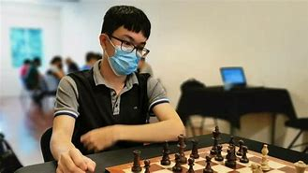
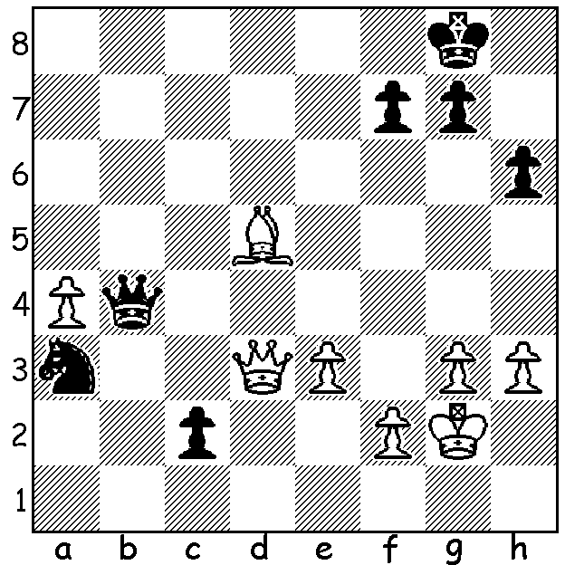
Parham Maghsoodloo vs Tin Jingyao 2021 Tin Jinhyao
In an attempt to halt the queening of the c pawn
White finds the ingenious 1.Qg6! (1...Qe7 2.Qc6);
however Black has a brilliant winning move:

LATEST ON AUSTRALIAN OPEN
The 2023 Australian Championship (11 rounds) will be held from 2 - 10 January at the Rendevous Hotel, Scarborough. There will be an Open and a Minor section (Under 1600 ACF).To get early concession on entry fee submit your entry before deadline on Monday 12 December (entry forms at cawa.org.au).
For such an event a great deal of work is required not only prior to the event but also daily throughout the tournament. If you are not able to compete please consider volunteering as a helper, even if only for a day or two (contact faithteelp@gmail.com).
The top rated player is Tin Jingyao from Singapore. Tin, born in 2000 is rated 2562. He is a five times Singapore champion and represented his country in Chess Olympiads in 2014 and 2016. In July this year he became the youngest Singaporian to gain the title of Grandmaster.
Australia and WA's best chance lies in Temur Kuybokarov who is rated 2558. Temur,
orginally from Uzbekistan, became a Grandmaster when eighteen. Since coming to WA he has won a host of tournaments, both within Australia and abroad. He won the Australian Championship in 2020 and was Australian Open champion in 2017 and 2019, a title he will be keen to retain.

SOLUTION: 1...Qb7!! After 2.Bxb7 fxg6 White resigned: if 2.Qe4 Qxd5! 3.Qxd5 c1=Q.

