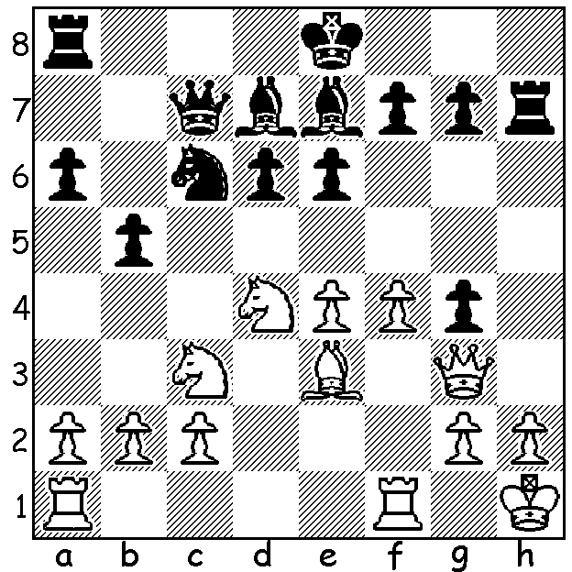
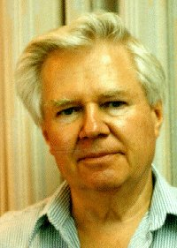

Cecil Purdy vs Wolfgang Leonhardt
(Australian Championship 1953) ;
Black to play wins a piece (5 moves - A young Wolfgang Leonhardt
find White's attempt to swindle):

2022 WESTERN AUSTRALIAN GRAND PRIX
The 2022 Western Australian Grand Prix consisted of 15 events played over weekends
throughout the year - five Classical, two Rapidplay, three Allegro and five Blitz. Prize winners in the three rating groups were: Open 1.Rebo Fu, 2. Tim Hare, 3.Patrick Gong: Major (Under 1850) 1. Teh Rui Gen, 2. Josh Davoll, 3.Eamon Harris: Minor (Under 1550) 1.Eric Deng, 2. Eamon Harris, 3.Naveen Ramnat Umasankar. Of note was the dominant performances of the junior players in all types of play. Two competitors deserving mention are Eamon Harris, who started the year with a rating of only 1102 yet finished 8th overall, 3rd Under 1800 and 2nd Under 1500, Dylan Gough, the only player to compete in every event as well as acting as DOP more than once, and finally
co-ordinator Ian MacAteer and the other Directors of Play.

The Perth Club concluded its busy 2022 schedule with a Handicap Lighting Tournament with the higher rated player having 3mins + 2sec per move and the lower rated player receiving 5min + 3sec. The final round deciding game brought together junior Jamie Laubbacher, the 2021 West
Australian Champion, and 93 year old Wolfgang Leonhardt, WA Champion eight times between 1954 and 1972, and this time age triumphed over youth.

SOLUTION: 1...Bh4! (deflecting the queen) 2.Qxg4 Nxd4 3.Bxd4 e5! (attacking queen and
bishop) 4.Nd5! Qb7! (not 4...Qc4 5.Qxd7+! Kxd7 6.Nb6+ nor 4...Qxc2 5.Qf3 exd4 6.Rfc1 / 7.Nc7+) 5.Qd1 exd4 and White soon resigned. Cecil Purdy, one of the greats of Australian Chess, six times Australian Champion and the first Correspondence World Champion in 1959 (well before chess engines!).

