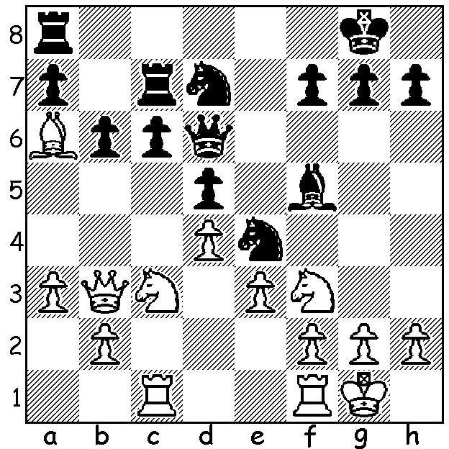
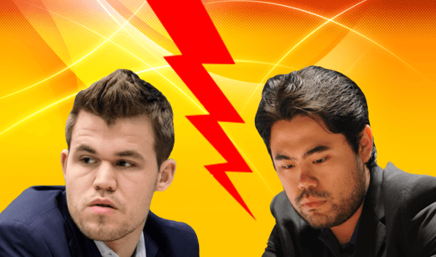
Magnus Carlsen vs Hikaru Nakamura
(2022 Speed Chess Final):
How does White gain material?

2022 WORLD SPEED CHESS CHAMPIONSHIP
The finals of the World Speed Chess Championships, hosted by chess.com, were played over one month, finishing earlier this week. Sixteen of the world's best players including Magnus Carlsen, Hikaru Nakamura, Ian Nepomniachtchi, Ding Liren, Fabiano Caruana, Wesley So, Levon Aronian and Maxime Vaxhier-Lagrave, competed in this knock-out event. Each match consisted of three segments, 90 mins of 3 mins + 1 second, 60 min of 3 min + 1 sec and 30 mins of 1 min + 1 sec. This meant no limit on number of games played during each session. The final brought together
the top two players, world champion Carlsen, winner in 2017, and winner 2018-2022 Hikaru Nakamura. Their rivaly over the years in speed chess can be compared to classic chess rivalries between Gary Kasparov and Anatoly Karpov who played five matches for the world title between 1984 and 1990. In the speed final Nakamura gained a early sizeable lead before Carlsen magaged to equalise at 11.5 each before Nakamura finally scraped home 14.5-13.5.

2022 AUSTRALIAN OPEN CHAMPIONSHIP: not long to go before the first round on 2nd January at Rendezvous Hotel Scarborough. Visitors are welcome to attend and the Chess
Association is keen to add to the volunteers who will be assisting (particularly in going through scoresheets and need not be for the whole tournament). Please check cawa.org.au.

SOLUTION: 1.Nb5! cxb5 2.Rxc7 Qxc7 3.Qxd5 forking two unprotected pieces.

