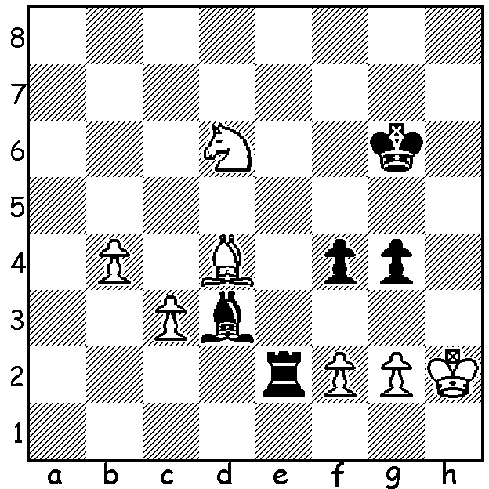

Evgeny Tomashevsky
vs Magnus Carlsen
(2022 World Rapid):
How does Black win?

2022 WORLD RAPIDPLAY CHAMPIONSHIP
Like other top sports players around the world, for many the world's best chess players the festive season is not a time for feasting and drinking and generally over-indulging. Instead 178 of them turned out on Christmas Day in Kazakhstan for the first few rounds of the 2022 World Rapid Championship. World champion Magnus Carlsen was one of four early leaders with 4.5/5 of the
eleven rounds. One of his victims was last year's winner Nodirbek Abdusattarov (Uzbekistan) who beat Carlsen in last year's event. In an interview, when asked if he had any further ambitions in the game, Carlsen replied, "I love the game, I love playing, so that's all the ambition I need and why I continue competing in the events I enjoy." Other prominent scores: Ian Nepomniatchtchi 4, Hikaru Nakamura 3.5. Former Australian champion Bobby Cheng is doing well with 3/5. In the Womens World Rapid, which is being played at the same venue with 98 players, three times European
champion Valentina Gunina (Russia but playing under the FIDE flag) leads with 4/4.

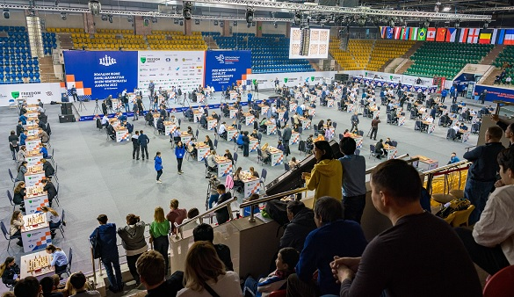

SOLUTION:
With his opponent having missed the chance to advance his queenside passed pawns, Carlsen's
advance on the kingside proves decisive. 1...g6+! (deflection sacrifice) 2.fxg (2.Kg1 Re1#) 2...f3 3.g4 Rxg2+ 4.Kh3 f2! and White resigns.

