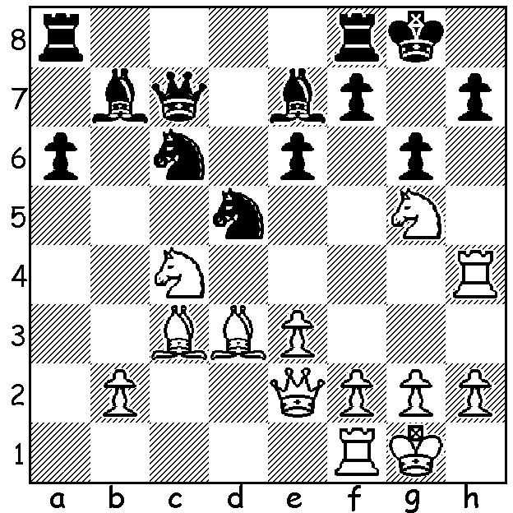
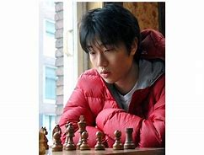
Daniil Dubov vs Nihal Sarin Bobby Cheng, Australia's only
(2023 World Rapid): Black's representative at the World Rapid.
1...Nd5 attacking knight and His fine score plus his excellent results
bishop seems to break White's at the last Olympiad helped to get him
attack. However Black is in voted 2022 Australian Player
for a big shock. of the Year.

2022 WORLD RAPIDPLAY CHAMPIONSHIP (Concluded)
World champion Magnus Carlsen maintained his lead to win the World Rapid Championship,
finishing with 10 points from 13 games (not 11 as I stated last week) although a blunder resulting in a loss in Rd 11 enabled his conquerer Russian Vladislav Artemiev and 19 year German Vincent Keymer to pull level. However Carlsen's draw and a final round win could not be matched by his rivals leaving the world champion with his fourth world rapid title. Keymer and fast finishing
Fabiano Caruana were a half point behind on 9.5. Former Australian champion Bobby Cheng
finished strongly to score 7.5 (41st-54th), the same score as Hikaru Nakamura. The Womens World Rapid was won by women's world champion Zhongyi Tan with 8.5/11.

2023 AUSTRLALIAN OPEN CHAMPIONSHIP
The Australian Open began this week at the Rendezvous Hotel, Scarborough, with 114 players in the Open and another 65 in the Minor Championship (Under 1600 ACF rating). Defending
champion, West Australian Temur Kuybokarov, got off to a good start winning his first three games.

SOLUTION: 2.Qh5!! gxh5 3.Bxh7#. The power of the Harrwitz (or Parallel) Bishops!

