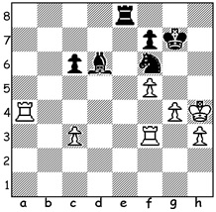
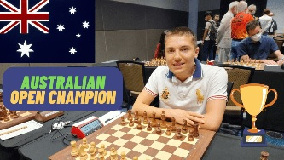

Yi Liu vs Darryl Johansen Temur Kuybokarov,
2023 Australian Open, Rd 11: 2023 Australian Open Champion
Find the quickest win for Black.

TRIUMPH FOR WA GRANDMASTER
WA Chess Grandmaster Temur Kuybokarov has won the Australian Open Championship, played at the Rendezvous Hotel, Scarborough, in a dominant display, unbeaten on 9.5 points from eleven games, finishing a point ahead of his nearest rival. One hundred and twelve players competed from such countries as Singapore, Vietnam, China, Malaysia, New Zealand, Serbia and Fiji as well as
Australians from all over the country. This was the first time Western Australia has held the
tournament since 1978. Born in Uzbekistan, twenty-two year old Temur arrived in Australia in 2000 together with his parents and was soon able to obtain Australian citizenship. He gained his Grandmaster title aged 18 and has dominated the sport in Australia winning the last three Australian Opens in 2018, 2020 and now 2023 as well as the Australian Championship (limited to the leading Australian players) in 2020 and 2022. Temur was voted Australian Plyer of the Year in 2020 and 2021 and represented Australia in the 2022 Chess Olympiad in Chennai, with his score of six points from nine games helping Australia to its best ever result in coming 30th in the 188 nation
competition. More on Open next week.

SOLUTION: 1...Rh8+ 2.Kg4 Ne4+! 3.Rxe4 f6#. Now 63, Darryl is a three times Australian Open Champion and six times Australian Champion.

