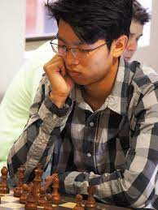
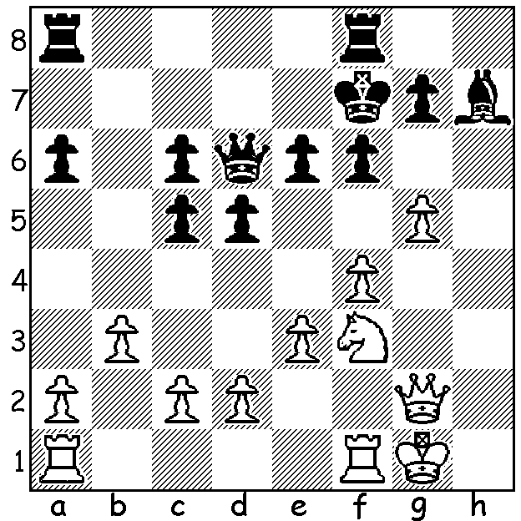

David Ellis vs Yu Leiming Patrick Gong
2023 Australian Open, Rd 4: =3rd Australian Open
White to play and win. 2nd Australian Blitz

AUSTRALIAN OPEN CHAMPIONSHIP (cont)
As reported last week WA Chess Grandmaster Temur Kuybokarov won the Australian Open
Championship, played at the Rendezvous Hotel, Scarborough, unbeaten on 9.5/11, a point ahead of his nearest rival, Singaporean GM and top-rated Tin Jingyao. Equal third were James Morris (Vic), Darryl Johansen (Vic), Qi Mars (China) and Patrick Gong (WA). Patrick also came second in the one-day Blitz event scoring 9/11 (winner James Morris 11/11). Also a number of other West Australians won rating prizes: in the Open - Dennis Holland, David Ellis, Tjermin Gunawan, all 7/11 (11th-21st), as well as in the Blitz - Marc Vliestra, Rebo Fu (both 8/11), Bozidar Mandic (7.5) , Jamie Laubbacher, Trent Gulley, Herbert Cadag (all 7/11). In the Australian Minor (for lower rated players) winner was Jayden Arav (NSW) with 8.5/11. Chintushig Chinbat (WA) was equal 2nd with 8/11 and Nick Ley and Hatmoniche Deng (both WA ) won rating prizes with 7/11. Thanks are due to all the organisers, officials and helpers (too many to mention) for their efforts in ensuring a most successful and enjoyable tournament for the 113 players in the Open and 51 in the Minor.

IRANIAN PLAYERS ACTION
Two Iranian women, both competing in the World Rapid and Blitz Championships, held in
Kazakhstan at the end of December, followed other Iranian sportswomen in abandoning their hajibs (scarves) as a protest following the death of Masha Amini in April 2022, taken into custody for not wearing the hajib.

SOLUTION: Black's 1...Kf7, played to enable his rooks to contest the h & g files as well as
remove his king from danger, allows 2.g6+! Bxg6 3.Ne5+! Ke8 (3...fxe5 4.fxe+ wins the queen) 4.Qxg6+ and Black resigns after another three moves.

