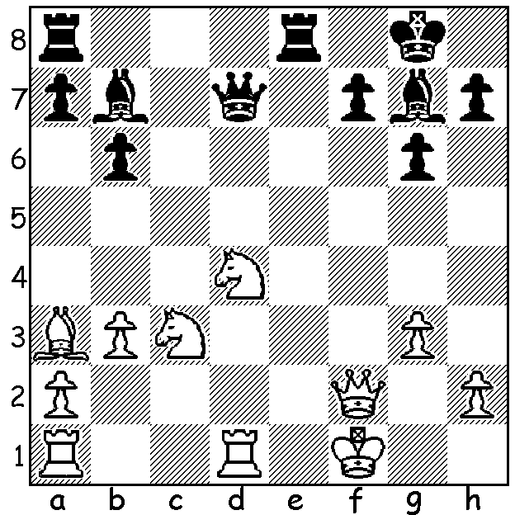
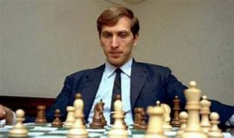
Bobby Fischer
Robert Byrne vs Bobby Fischer, 1963
Black to play and win:

CHESS AND THE MEDIA
A question: Why are the general media (TV, radio, newspapers) not interested in Chess? There have been very few occasions when Chess has made the news - the Bobby Fischer vs Boris Spassky World Championship match in 1972 with its cold war struggle between an ecceentric loner and a product of the Soviet system, the loss by Garry Kasparov to computor Deep Blue in 1997 and the physical assault by England's Daniel Gormally on Armenia's Levon Aronian over Australian beauty Arianne Caoili at the 2006 Chess Olympiad (Gormallygate). Despite the fact that Chess is played regularly by over 600 million adults worldwide it is in general ignored by the popular media. When Perth hosted the 2023 Australian Championship earlier this month, attracting competitors from the eastern states, Asia and even UK, with the event won by a West Australian, I do not believe there was any media coverage in WA. Chess is certainly not a spectator sport, even the frenzied Blitz games (with silence reigning you can't clap or cheer), perhaps because of the public's general ignorance of the rules and their worship of the physical athlete and their suspicion of intellectual activity, the same mindset that has our government spending millions on Olympics and World Cup Football but unwilling to give a cent to support our Chess Olympiad team. Perhaps we need more Queens Gambits!

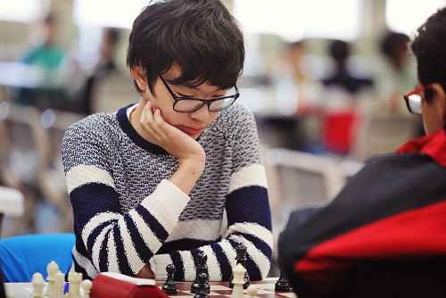
2023 AUSTRALIAN JUNIOR CHAMPIONSHIPS
(Melbourne): WA was well represented by a number of
our leading juniors with Rebo Fu outstanding, winning
the Under 16 Championship, the Under18 Blitz and the
Under18 Problem Solving.

SOLUTION: 1.Qh3+ 2.Kg1 Re1+! 3.Rxe1 Bxd4
4.Qxd4 (or Re2) 4...Qg2#.

Rebo Fu

