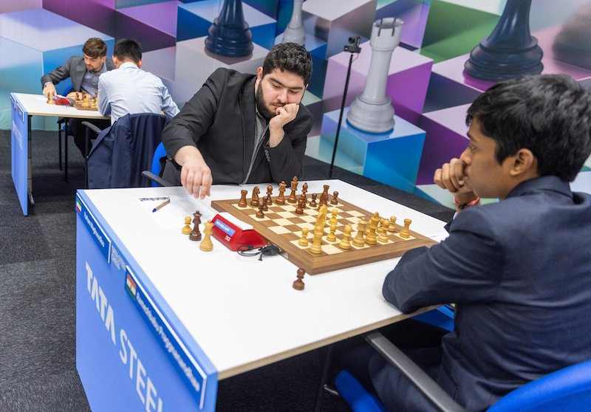
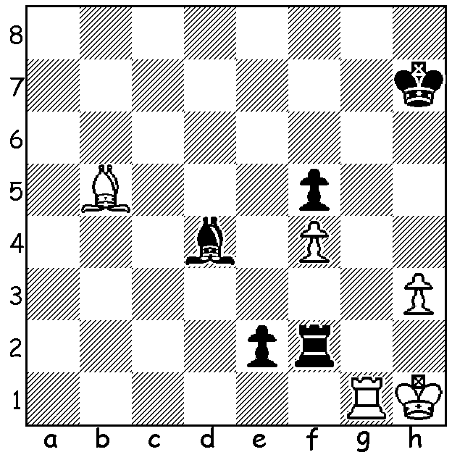
Rameshbabu Praggnanandhaa Praggnanandhaa (W) vs Maghsoodloo
vs Parham Maghsoodloo
(Tata Steel 2023): Black to play and win:


WA PLAYERS EXCEL IN OCEANIA ZONAL
A number of mainly young West Australians recently competed
in the Oceania Zonal Tournament in Melbourne (248 players).
Entering the final round former Australian champion Zhao Zang-
Yuan (NSW) led with 7/8. However his loss to veteran Stephen
Solomon (Qld) allowed six players to leapfrog him to 7.5,
including WA's top players Temur Kuybokarov, who recently
won the Australian Open Championship in Perth, and Patrick
Gong. Temur then defeated Gary Lane (NSW) 2-0 in a play-off
(between the two leading players according to scores of their
opponents) to gain a place in World Cup (Knockout). Patrick's
reward for his excellent result was the gaining of his IM Temur Kuybokarov

(International Master) title. Other WA scores: Rebo Fu 6.5, Adam
Kelly 6, Oscar Gao, Neville Shah 5, Saminda De Vas, Yonan De
Vas, Iker Mendez Hernandez, Shannon Koh 4.5.
In the Womens Zonal (41 players), won by WGM Julia
Ryjanova (Vic) with 8/9. WA's leading female players Kathryn
Hardegen and Celine Ong scored 5.5 and 4.5 respectively.

SOLUTION: 1...Rh2+!! (deflection sacrifice and discovered
attack) 2.Kxh2 Bxg1+ 3.Kxg1 e1=Q. No other move wins -
1...Bc3 2.Bxe2 Rxe2 3.Rg5 winning Black's last pawn.
Both players are child prodigies, Indian Praggnanandhaa
became a GM at 12 and Maghsoodloo, who is a three-time
Iranian champion and was World Junior Champion in 2018,
a GM at 16.
Patrick Gong

