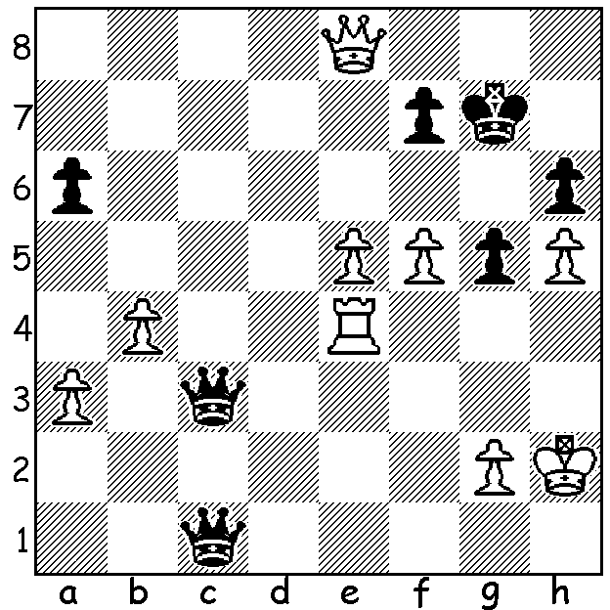
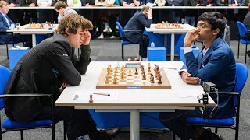
Magnus Carlsen vs Rameshbabu Praggnanandhaa (Tata Steel 2023). Despite his 2 queens Black is faced with being mated. Find a defence against White's f6+:

CARLSEN LOSES TWO GAMES IN A ROW
In December Magnus Carlsen won the World Blitz Championship ahead of his fiercest rival in fast chess, Hikaru Nakamura. Besides the Blitz Carlsen also holds the world title in classic chess and rapidplay. The only world championship title he does not hold is the Fischer Random or Chess960 where he lost to Ian Nepomniachtchi in the semi-final (Nakamura won the event).
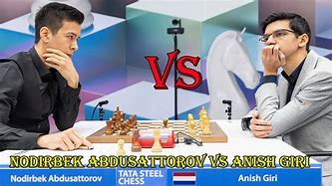
Carlsen would have gone into the 2023
Tata Steel tournament (called the
Wimbledon of Chess) as favourite, having
been champion eight times. However in
this year's 14 player event he suffered
consecutive losses in rounds 4 and 5 to
Anish Giri (Netherlands) and 18 year old
Nodirbek Abdusattorov from Uzbekistan.
Despite a strong finish he ended up =2nd
with Abdusattorov on 8/13, a half point
behind winner Anish Giri. For Giri it was
a case of no longer the bridesmaid after having been runner-up five times.
The tournament combined established leading players with a number of the most successful of younger generations (eg Abdusattorov who won the 2021 World Rapid Championship).

The SOUTHERN SUBURBS OPEN will be held will be held at Leeming Primary on seven successive Tuesdays starting 14 February. If interested contact Andrew 0407421084.

SOLUTION: 1...Qc7 (defends the f pawn) 2.f6+ Kh7 3.Qf8 Qxe5+!! (deflection) 4.Rxe5 Qf4+ 5.Kg1 Qc1+ 6.Kh2 Qf4+ 7.Kg1 Qc1+. White avoided the draw by repetition with 8.Kf2, giving up his rook after 8...Qf4+ 9.Ke2 Qxe5+. However the game still finished drawn after a queen exchange and both side promoting.

