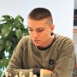
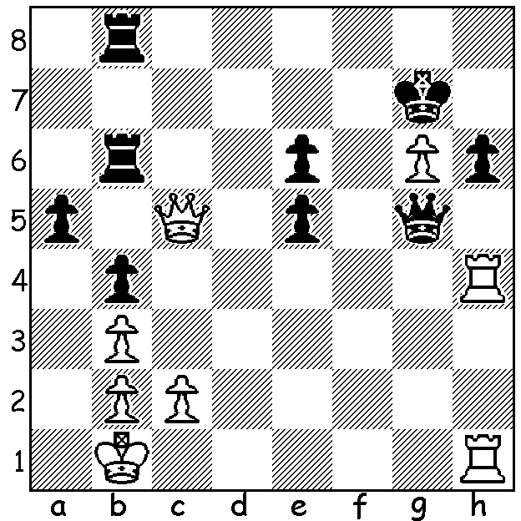

Temur Kuybokarov vs Jason Li: Temur Kuybokarov
Oceania Zonal 2023: a surprise move
by White leads to a quick mate:

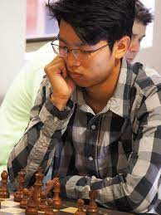
2023 PERTH OPEN
The Perth Open, played last weekend at North Woodvale
Primary, attracted 44 players. Joint winners were WA's
top two players, Australian champion Temur Kuybokarov
and Patrick Gong with 5.5/6, with Tim Hare and Reh Rui
Gen equal third on 4.5. Best junior was Rebo Fu with 4pts.

BRUTAL CHESS TACTICS
Brutal Chess Tactics is a book byTemur Kuybokarov in
collaboration with Ortik Nigmatov, one of Uzbekistan's
leading players. The book promises to uncover unique
tactical ideas that your opponents won't even consider.
The book seems geared to players serious about improving
and prepared to put in some serious work. There are three
sections: Elderado (with 100 exercises for ratings 1600-
2200), Brutality (rating 2200-2500) and GM Challenge Patrick Gong
(rating 2500-2800). Not the usual book on tactics where
more often than not the combinative idea immediately strikes you but one which demands real
deep thought to unearth the unusual. If you are keen to improve, this book might well be for you.

SOLUTION: 1.Rg1!! and if 1...Qxh4 2.Qc7+ mating.

