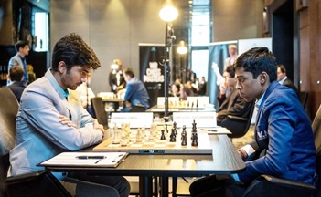
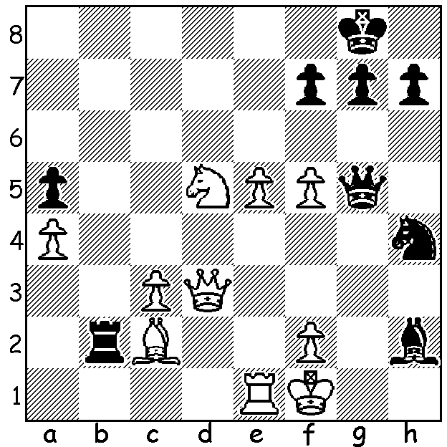
Gukesh (W) vs Pragg (WE Masters)
D. Gukesh vs R. Praggnandhaa
2023 WR Masters Rd 2:
Black appears to have a dangerous
attack but White gets in first (4 moves):

2023 WR MASTERS
The 2023 WR Masters being played in

Dusseldorf has brought together five
established leading players, Ian
Nepomniachtchi (Russia), Anish Giri
(Netherlands), Wesley So and Levon
Aronian (USA), Jan-Krzystof Duda
(Poland) and five of the world's most
talented younger players, Indians
Dommaraju Gukesh (aged 16) and
Rameshbabu Praggnandhaa (17),
Nodirbek Abdusattarov (Uzbekistan
18), Andrey Espenko (Russia 20) and
local Vincent Keymer (18). Players are Rosenstein (B) playing off-hand game
all rated between 2675 and 2793 (Nepo with Kramer
the top). Classic time limits apply and
will be the same as in the forthcoming Nepo vs Ding Liren world championship match. The event is the concept of 32 year old Wadim Rosenstein whose Dusseldorf company the WR Group, a project and service company in engineering and construction, provides the sponsorship. Rosenstein was a keen chess player in his youth and now, although with his work takes up nearly all his time, he still find occassions to play and describes himself as 'an avid hobby player'. He has also expressed an interest in promoting 'bug-house' or transfer chess, a game with partners (very popular with our young players).

2023 WA ALLEGRO CHAMPIONSHIP
The WA Allegro Championship will be held on Sunday 12 March at the Saint George Hotel, Innalo.
There will be nine rounds with 12 minutes for each player with 3 seconds increment per move. Check details and booking cawa.org.au

SOLUTION: 1.Ne7+!! (a multi purpose sacrifice, exposing the back rank to a queen mate and deflecting the queen) 1...Qxe7 2.f6+ (discovered attack by Q + B battery) 2...gxf 3.Qxh7+ Kf8 4.Qh8#. If 2...Qc7 3.Qxh7+ Kf8 4.Qxg7#. A fine game from India's two young stars.

