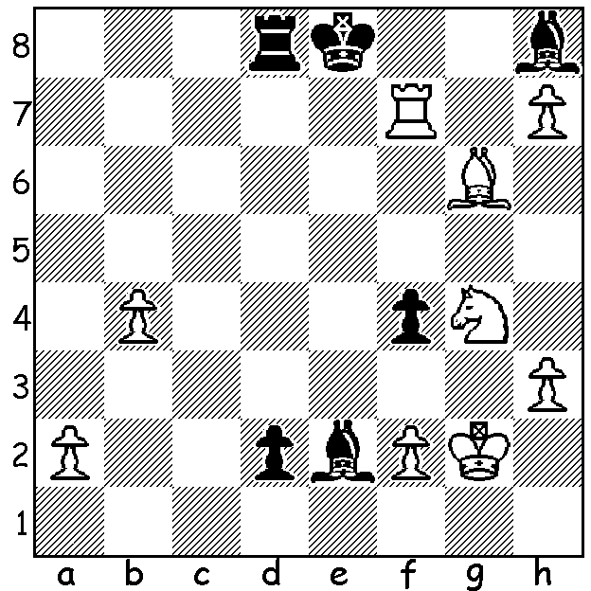
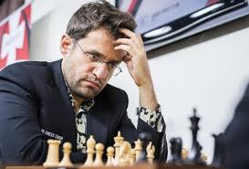
Levon Aronian vs Alexander Grischuk:
White declines the draw by perpetual check to mate in 3

2023 WR MASTERS
Wadim Rosenstein must have been delighted with his new tournament in Dusseldorf in which five of the world's most promising young players and five of the top established players competed with one of the young brigade, 16 year old Indian Dommaraju Gukesh, tying for top place with Russian Ian Nepomniachtchi and Levon Aronian (USA), all 5.5/9. The ensuing Rapid play-off resulted in victory for Aronian who won three games straight, beating Gukesh twice and Nepo once, (Nepo having lost his one play-off game vs Gukesh). Other scores: Wesley So 4.5, Jan-Kryzsztof Duda, local Vincent Keymer, Andrey Esipenko, Nodibrek Abdusattarov, Anish Giri and Rameshbabu Praggnandhaa all 4.

2023 WA ALLEGRO CHAMPIONSHIP
The WA Allegro Championship will be held on Sunday 12 March at the Saint George Hotel, Innaloo.There will be nine rounds with 12 minutes for each player with 3 seconds increment per move. Check details and booking cawa.org.au

SOLUTION: 1.Nf6+!! (deflection sacrifice) 1...Bxf6 2.Rg7! (discovered check with obstruction) 2...Kf8 3.h8=Q#.

