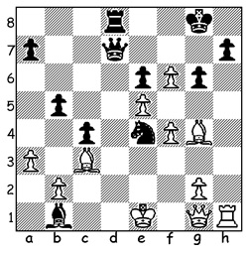


John-Paul Wallace vs Rasmus Svane, 2014:
How does White defend against ...Nxc3 & ...Qd2+ & gain a winning position?

AUSTRALIAN STRIVING TO BECOME GM
Many readers will be unfamiliar with the name John-Paul Wallace, a 46 year old Australian who left Australia to pursue his chess passion in London. Wallace became the youngest ever Australian champion in 1994 aged 17 and won the Australian Open in 2003. He represented Australia in two Olympiads, Moscow 1994 and Armenia 1996. This year he married and moved from the UK to live in Norway and recently won the 100 player Kragero Resort International in Norway with 7/9 ahead of 12 GMs (Grandmasters), including GM Bobby Cheng, also a former Australian champion.This result earned him his second GM norm. A third norm is required to receive nomination for the GM title.

2023 WA ALLEGRO CHAMPIONSHIP
The WA Allegro Championship will be held tomorrow, Sunday 12 March, at the Saint George Hotel, Innaloo.There will be nine rounds with 12 minutes for each player with 3 seconds increment per move. Check details and booking cawa.org.au

SOLUTION: 1.Bxe6+! (deflection sacrifice) 1...Qxe6 2.Qxa7+ Qf7 (2...Qd7 3.Qxd7 Rxd7 4.e6 wins or 2...Rd7 3.Qa/b8+ Kf7 4.Rxh7#) 3.Qxf7+ Kxf7 4.Rxh7+ & wins (cont. 4...Ke6 5.g4! Nxc3 6.Re7+ Kd5 7.bxc3 and the pawn avalanche wins).

