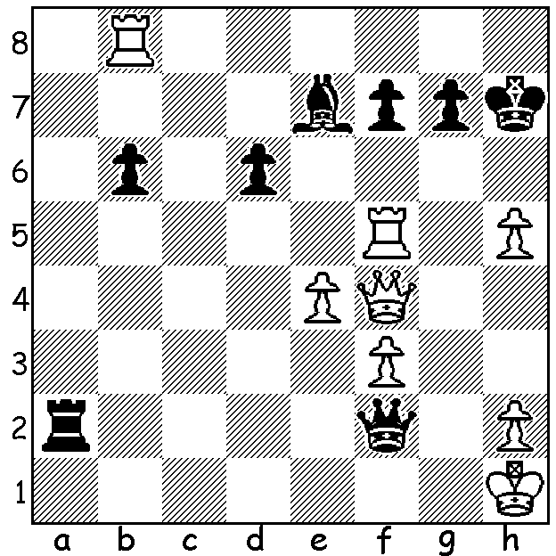
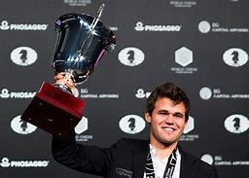
Magnus Carlsen vs Sergey Karjakin Magnus Carlsen holds aloft the World
(World Championship 2016): Championship Cup after defeating Karjakin.
can White defend against mate?

THE END OF AN ERA
Norwegian Magnus Carlsen has played his last Classic game of chess as world champion after declining to defend his title, citing lack of motivation. The next world champion will either be Ian Nepomniachtchi or Ding Liren (China), winner and runner-up in the 2022 Candidates. Carlsen at 22 years old won the title in 2013, defeating defending champion Indian Vishi Anand 6.5-3.5 (+3 =7 -0) in a 12-game match in Chennai, India. Anand was his first challenger but he was again defeated, this time 4.5-6.5 (+1 =7 -3) in Sochi, Russia, in 2014. Carlsen's second challenger was Russian Sergey Karjakin in New York in 2016. After 12 games each player had won one game and the match was decided in four rapidplay games with Carlsen winning 3-1 (+2 =2). His third challenge came from Fabiano Caruana (Italy, now US) in London in 2018. After all 12 games were drawn Carlsen won three successive rapidplay games to retain the title. His final challenger was Russian Ian Nepomniachtchi whom he defeated 7.5-3.5 (+4 =7 -0) in Dubai in a 14-game match.
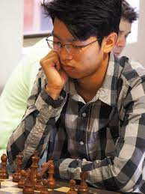

2023 WA ALLEGRO CHAMPIONSHIP
The WA Allegro Championship attracted 48 entries last Sunday at the St George Hotel, Innaloo and was won by IM Patrick Gong with 9/9. (more information next week)

SOLUTION: There is no DEFENCE against Black's threats.
However White's ATTACK gets in first - 1.Qh6+!! resigns
(1...gxh6 2.Rxf7# or 1...Kxh6 2.Rh8#). This spectacular finish
concluded the Carlsen-Karjakin match.

IM Patrick Gong

