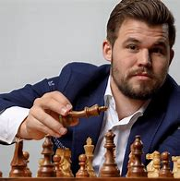
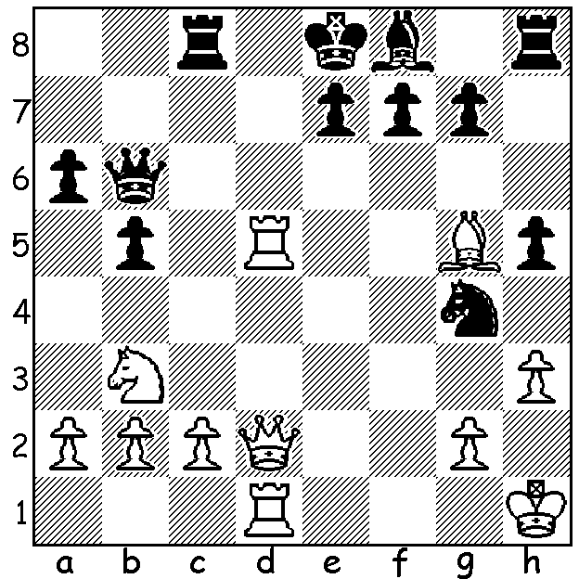
Magnus Carlsen vs
David Kjartansson 2006
White to play and win (3 moves):

MAGNUS NOT RETIRING
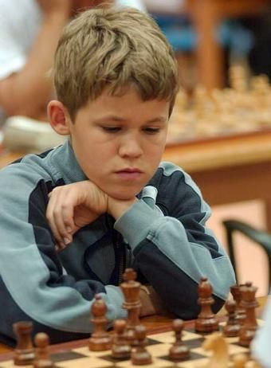
Despite giving up the world title, Norwegian Magnus Carlsen
has no plans to retire from tournament play. Let's take a
moment to look at the thirty-two year old's successes outside
of world championship matches. A child genius, Magnus could
solve 500 piece jigsaws at the age of two and at four was
assembling Lego sets intended for 11-14 year olds. His father
taught him chess at five and he tied first in the 2002 World
Under 12 Championship. He became a Grandmaster at aged
13 years four months, the youngest at the time. Up to the
present time he has been four times World Rapidplay champion,
six times world Blitz champion, No. 1 in FIDE rankings since
2011 (trailing only Garry Kasparov in time spent as No. 1), with
a peak rating of 2882, the highest of all time and has the longest
unbeaten run of 125 games in Classic chess between 2018 and
2020. His first places in top tournaments are too numerous to
mention and he can certainly expect to add to this number in
the years ahead. A young Magnus Carlsen

2023 WA ALLEGRO CHAMPIONSHIP
The WA Allegro Championship, 48 held at the St George Hotel, Innaloo, with 48 players, was won by IM Patrick Gong with 9/9 (as reported last week). Other leading prize winners: 2nd Rebo Fu (7.5/9), 3rd and senior champion Bozidar Mandic (7), 4th Oscar Gao (6.5).

WILLETTON OPEN Sunday 9th and Monday 10th April. Check.cawa.org.au (calendar)

SOLUTION: 1.Rc5! (clearance and deflection sacrifice): if 1...Rxc5 2.Qd7# and if 1...Qb7 2.Na5 forces the queen from defence of d7 or c8.

