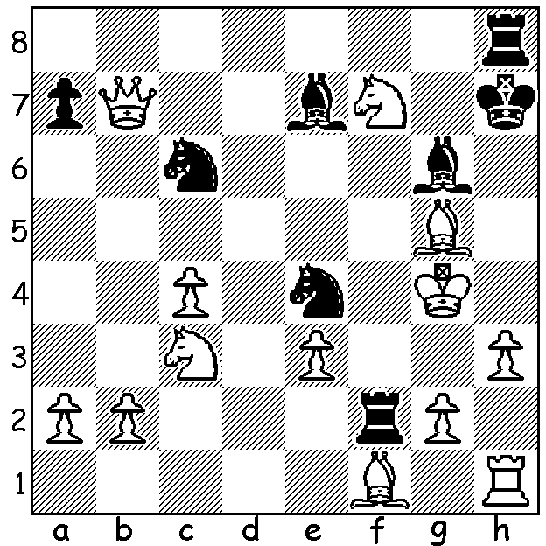
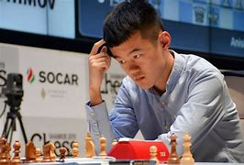
Ding Liren
Jinshi Bai vs Ding Liren 2017
Black to play mates in 3 or 4:

WHO WILL BE NEXT WORLD CHAMPION?
There will be a new world champion following the coming 14-game match in Kazakhstan, April 7 to 1 May, between Ian Nepomniachtchi (Russia) and Ding Liren (China), the winner and runner-up in the 2022 Candidates Tournament. Ding certainly had good fortune going his way with Magnus Carlsen relinquishing the title, Ding's late invitation to the Candidates after Russian Sergey Karjakin was disqualified for supporting the Russian invasion and the decision of FIDE to have a match for the title when previously, after Bobby Fischer declined to defend the title, Candidates winner Anatoly Karpov was declared world champion. Nevertheless Ding is certainly a worthy challenger, being the second highest rated player in the world at 2811, with only Carlsen above on 2859. In 2016 Ding was the highest rated player in Blitz chess and in 2016 created a world record, going 100 classic games without defeat (a record since broken by Carlsen in 2019 with 125). Ding is a three-times Chinese champion and was winner of the 2019 Grand Chess Tour and the 2019 Sinquefield Cup (next week Nepo).

WILLETTON OPEN (WA Grand Prix) Sunday 9th and Monday 10th April at N Woodvale Primary: see cawa.org.au

SOLUTION: 1...Ne5+!! (deflecting the knight from defending g5 & h6 or bringing his last piece into the attack); if 2.Nxe5 Bf5+ 3.Kh5 Kg7+ 4.Bh6+ Rxh6#; if 2.Kh4 Kg8+! 3.Nxh8 (3.Nh6+ Rxh6#) 3...Bxg5#. Called 'The Chinese Immortal', this game brings to mind the famous sacrificial king hunts of the nineteenth century.

